

ONDO STATE HEALTH SECTOR

2017-2019
Medium Term Sector Strategy (MTSS)

October, 2016

Foreword
The Medium Term Sector Strategy (MTSS), a complementary component of the Medium-Term Expenditure Framework (MTEF), represents a vital link in the process of translating the long and medium-term health reform strategies of the Ondo State Government from 2017 to 2019 into the spending reality of the Annual Budgets. The Medium Term Sector Strategy of the Health Sector as presented in this document sets out the fully costed initiatives and expenditure plans through which the Sector seeks to contribute to the delivery of qualitative and accessible health care service delivery of government over the period 2017-2019 within the confines of limited scarce resources.
The Medium Term Sector Strategy of the Health Sector was developed by the MTSS Steering Committee and the Sector Planning Team (SPT); comprising, the Honourable Commissioner, the Permanent Secretary, Directors from the Ministry, Departments and Agencies, all key officers from the main Ministry and the Departments and Agencies; with the assistance of the Ministry of Economic Planning and Budget (MEPB) which acted as the coordinating Ministry over the MTSS process.
I wish to commend all stakeholders within the Health sector who tirelessly contributed to the development of the MTSS Document which will serve as an important instrument for guiding policy direction and delivering value for money, in addition to contributing adequately to the socio economic status, improved health care service delivery and expected health outcomes in Ondo State and Nigeria as a whole.


Dr. E.T. Oni
Permanent Secretary (MOH)
October, 2016

Acknowledgements
- The immense contribution(s) of the Ministry of Economic Planning & Budget for the sense of direction towards achieving and accomplishing this document is hereby acknowledged. Also worthy of note are the contributions of the World Bank and the following stakeholders to the success of this document:
- Honourable Commissioner for Health,
- Permanent Secretary of the Ministry of Health,
- Secretary of Hospitals Management Board
- Executive Secretary of Ondo State Primary Health Care Development Board (OSPHCDB),
- Directors and Staff of all MDAs in the Health Sector,
- The Principals of the Schools of Nursing, Midwifery and Health Technology,
- The State House of Assembly for enacting relevant laws and approval of the State’s annual budget; Central planning MDAs –SMEPB and SMOF – for providing guidance on the MTSS and resource envelopes available to each sector;
- Sector line ministries and other MDAs for developing the suite of programmes/activities to be implemented by the sector through the MTSS period and for drafting the MTSS document;
- Civil Society and the general public for providing feedback on the current levels of service provision this establishes the gaps in service provision and informs the formulation of new strategies; and
- The Health Sector MTSS Planning Team.

Contents
Foreword ii
Acknowledgements ii
Contents ii
Table of Figures ii
List of Tables ii
Table of Acronyms ii
Executive Summary ii
Chapter 1. Introduction 2
1.1. Aims and objectives of the document 2
1.2. Summary of the process used 2
1.3. Outline of the Structure of the Document 2
Chapter 2. The Sector and Policy in the State 2
2.1 A brief background to the State 2
2.1.1. Ondo State 2
2.1.2. Geography 2
2.1.3. Economy 2
2.2 A brief introduction to the Sector 2
2.3 The current situation in the Sector 2
2.4 Overview of the sector’s institutional structure 2
2.5 Statement of the sector’s mission, vision and core values 2
2.6 Sector Policy 2
2.7 The sector’s goals and programmes for the MTSS period 2
Chapter 3. The Development of Sector Strategy 2
3.1 Major Strategic Challenges 2
3.2 Resource Constraints 2
3.3 Contributions from partners 2
3.4 Program connections between Sector MDAs 2
3.5 Outline of Key Strategies 2
3.6 Justification 2
3.7 Result Framework 2
3.8 Responsibilities and Operational Plan 2
Chapter 4. Three Year Expenditure Projections 2
4.1 Performance Monitoring and Evaluation 2
4.2 Public Involvement 2
5.1 Identifying Sources of Data against the Results Framework 2
5.2 Conducting Annual Sector Review 2
5.3 Organisational Arrangements 2

Table of Figures
Figure 1: Organogram of the Health Sector 2

List of Tables
Table 1: Operational Definition of Sector's Core Values 2
Table 2: Summary of 2015 Budget Data for the Sector 2
Table 3: Summary of 2016 Budget Data for the Sector (Jan-April/May 2016) 2
Table 4: Capital Costs Commitments 2
Table 5: Personnel Costs – Existing and Projected 2
Table 6: Overhead Costs – Existing and Projected 2
Table 7: Summary of Cancelled/Shut Down Projects 2
Table 8: Grants and Donor Funding 2
Table 9: Summary of Projects’ Expenditures and Output Measures 2
Table 10: Data Sources for Outcome and Output KPIs 2

Table of Acronyms
Acronym | Definition
AIDS | Acquired Immune Deficiency Syndrome
CEMDOS | Confidential Enquiry into Maternal Deaths in Ondo State
CSO | Civil Society Organizations
DHIS | District Health Information Software
DLI | Disbursement Linked Indicator
DST | Dental Student Technician
EMS | Emergency Medical Services
FAST | First Aid Support Team
GH | General Hospital
HDC | Health Development Committee
HIV | Human Immuno-deficiency Virus
HMB | Hospitals’ Management Board
HMIS | Health Management Information Systems
HR | Human Resource
HRH | Human Resources for Health
ICT | Information and Communication Technology
IEC | Information and Education Communication
IGR | Internally Generated Revenue
KCC | Kidney Care Centre
LACA | Local Action Committee on AIDS
LGA | Local Government Area
LM | Line Ministries
LMCU | Logistics Management and Coordinating Unit
MCH | Mother and Child Hospital
MDA | Ministry Department and Agency
MDCN | Medical and Dental Council of Nigeria
MEC | Millennium Eye Centre
MEPB | Ministry of Economic Planning and Budget
MICS | Multiple Indicator Cluster Survey
MTSS | Medium Term Sector Strategy
MoH | Ministry of Health
N&MCN | Nursing and Midwifery Council of Nigeria
NDHS | Nigeria Demographic and Health Survey
NHIS | National Health Insurance Scheme
NHMIS | National Health Management Information Systems
NISONMG | Nigerian Schools of Nursing and Midwifery Games
NPHCDA | National Primary Health Care Development Agency
ODSACA | Ondo State Agency for the Control of AIDS
ORIREWA | Ondo Routine Immunization Reaching Every Ward Always
OSPHCDB | Ondo State Primary Health Care Development Board
PHC | Primary Health Care
PMR | Performance Management Review
PMTCT | Prevention of Mother to Child Transmission
SACA | State Agency for the Control of AIDS
SMoH | State Ministry of Health
SON | School of Nursing
SPT | Sector Planning Team
SSH | State Specialist Hospital
SSHDP | State Strategic Health Development Plan
SURE-P | Subsidy Reinvestment Programme
SOM | School of Midwifery
TBAs | Traditional Birth Attendants
TBL | Tuberculosis and Leprosy

Executive Summary

The Ondo State Government is currently preparing the 2017-2019 MTSS document. This is to plan and improve the performance of the Health Sector.
The Year 2015 Budget analysis showed that out of N12,713,642,518.69 allocated to the health sector, N1,976,000,345.37 was expended, meaning a performance of 17.2%. Additionally in the Year 2016 so far from the calendar year between Jan-May, there has been a budget release of 3,708,576,301.23 out of the budget allocation of 13,900,236,540.11. This gives a budget performance of 26.68% midyear (May) which is bound to increase as the year progresses.
Further review of the budget revealed that the MDAs would have performed better but due to the economic recession the country is experiencing.
The preparation of the Health Sector 2017-2019 MTSS will set the pace for the 2017 budget and subsequent ones, as the 2016 budget for the State has been passed and approved. The budget for the year 2016 of Ondo State is N123,720,700,000.00 with a budget allocation of N14,305,790,540.27 (11.56% of the total budget) to the Health sector.

- Introduction
  - Aims and objectives of the document

The Medium Term Sector Strategy (MTSS) takes a prominent role as one of the major milestones in the cyclical chain of the Medium Term Framework. The MTSS document for the Health Sector is therefore developed to facilitate better harmonization of government policies and strategies with the budgetary process. It is believed that this document when finalized will help inform the development of feasible health programs and projects.
The MTSS is aimed at ensuring that within the given resource envelope, sector resources are deployed in consonance with clearly defined and accountable policy objectives of government of Ondo State.
The process seeks to ensure the achievement of sector targets through feasible and responsive plans where resources are efficiently and effectively deployed.
  - Summary of the process used
The MTSS of the Health Sector as set out in this document was formulated by the Sector Planning Team (SPT); comprising, the Honourable Commissioner, the Permanent Secretary, Directors from the Ministry, Departments and Agencies (MDAs), with the assistance of the Ministry of Economic Planning and Budget (MEPB) which acted as the coordinating Ministry over the MTSS process.
The formulation of the MTSS for the Health Sector was designed to rely on the inputs and support from a range of relevant stakeholders within and outside government who participated actively in the process to ensure that the expenditure plans take effect. These stakeholders include:
- Honourable Commissioner
- Permanent Secretary
- Heads of Departments and Agencies
- Sector Planning Team
- Civil Society Organizations (CSOs) and
- The key planning, budgeting and reform MDA of the Ondo State Government

The process involved the following steps:
- Review of all existing high level policies of government as it relates to the Health sector in line with the government’s strategies of ensuring improved health outcome.
- Confirmation of the Sector’s Goals and Programmes for 2017 – 2019 against the background of government’s strategies.
- Assessment of the existing budget commitments to the Health sector so as to determine the level at which these will accomplish the Goals and Programmes and existing resource commitment reality of the sector
- Development of proposals of projects, existing and new, required to achieve the Goals and Programmes of the sector as defined or validated.
- Use of the Scoring matrix to score projects. This is a veritable tool for planning programmes and projects that are existing and ongoing and completed.
- Prioritization of initiatives and development of detailed costing of each project.
- Identification of the phases of the cost of the prioritized projects over the period 2017 – 2019 and justification of projects based on their high priorities and importance
- Specification of Outputs, Outcomes, Performance Measures and Key Performance Indicators for each project identified in line with the envelope – i.e., the benefits of the projects to the good people of Ondo State.
- Finally, the Log frames of the projects present the goals and programmes of the MDAs in the health sector of Ondo State.

Ondo State high-level policy documents that deal with the Health sector were also reviewed; namely
- Ondo State Government State Strategic Health Development Plan
- Ondo State Caring Heart Agenda
- Ondo State Economic Empowerment and Development Strategy
- Ondo State Vision 20:2020
- Ondo State Operational Plan
The foregoing policy documents were reappraised to obtain relevant strategic issues, policy thrust, high-level strategies, performance measures and targets that form the basis of the health sector MTSS for the period 2017– 2019. Specifically, the review of the policy documents guided the development of the strategic goals, programmes, projects, performance measures, outputs, targets, and outcomes for the 2017– 2019 MTSS of the Health Sector. Highlights of the review are harmonized in the Ondo State Development Plan.

  - Outline of the Structure of the Document
The document was prepared sequentially thus:
Chapter one states the aims and objectives of the document as well as the procedures used in developing the MTSS for Health sector.
Chapter Two gives a brief background of Ondo State as well as discusses the Health Sector in the State by highlighting the institutional structure, current situation, the sector’s vision, mission and core values. The sector policies, goals and programmes for MTSS were also discussed.
Chapter Three states major strategic direction of the sector, resource constraint, contributions from partners, programme connection between sector’s MDAs, outline of key strategies, justification, result framework as well as responsibilities and operational plan.
Chapter Four discusses performance monitoring and evaluation as well as public involvement.
Chapter Five presents sources of data as against the result framework, annual sector review and organizational arrangement.

- The Sector and Policy in the State
  - A brief background to the State

Ondo State
Ondo State, generally referred to as the “Sunshine State”, was created from the defunct Western State on 3rd February, 1976. Before its creation, the State existed as the Ondo Province of the old Western State. The present Ondo State was formed when Ekiti State was carved out of it in October 1996. The State has land area of approximately 15,317sq kilometers representing 1.66 percent of the total surface area of Nigeria. The population of the State in the 1991 census figures was 2,249,548 while year 2006 census puts the population at 3,441,024 made up of 1,745,058 males and 1,715,820 females representing 50.42% and 49.58%, respectively. Ondo State has the longest coastline in Nigeria with considerable territorial waters offshore, rich in aquatic and mineral resources of significant quantity.

Geography
Ondo State is located within Latitude 5⁰ 45’ and 7⁰ 52’N and Longitudes 4⁰20’ and 6⁰05’ E. The Administrative capital is Akure while there are 18 local governments in the State and is bounded in the North by Ekiti and Kogi States, in the East by Edo State, on the West by Osun and Ogun States and in the South by the Atlantic Ocean. Ondo State is located entirely within the tropics.
The tropical climate of the State is broadly of two seasons: rainy season (April-October) and dry season (November – March). The temperature throughout the year ranges between 21ºC to 29ºC and humidity is relatively high. The annual rainfall varies from 2,000mm in the southern areas to 1,150mm in the northern areas. The State enjoys luxuriant vegetation with high forest zone (rain forest) in the south and sub-savannah forest in the northern fringe.
The geology of the State is made up of the basement complex. The basement complex is essentially non-porous and water can only be found in the crevices of the complex. The rock types include quartz, gneisses and schists. This basement complex primarily underlies the sedimentary layers which consist of cretaceous, tertiary and quaternary sediments deposited in the coastal basin.

Economy
The State’s Economy is basically agrarian with large scale production of cocoa, palm produce and rubber. Other crops like maize, Kolanut, yam and cassava are produced in large quantities. 65% percent of the State’s labour force is in the agriculture sub-sector.
The State is also blessed with very rich forest resources where some of the most exotic timber in Nigeria abound.
Ondo State is equally blessed with extensive deposits of crude oil, bitumen, glass sand, kaolin, granites and limestone. Therefore, the State has great potentials for rapid industrial growth in view of its raw materials base. The tourism potentials of the State is also high as its historical sites, long coastline, lakes, forest and cultural events can be developed for tourism. The fact that Ondo State is arguably the most Peaceful State in the Oil Rich Niger-Delta region, made her the most viable investment destination of all times.

  - A brief introduction to the Sector
The Health sector came into being in April 1976 as a consequence of the creation of Ondo State in February of the same year from the defunct Western State of Nigeria. Within the framework of the defunct Western State Health Management Board System, which came into force by Edict 12 of 1975 on 1st July of the same year, the newly created geo political block inherited the Akure Health Zones.
At inception, the Ministry of Health was divided into 8 divisions namely:
- Administration & General,
- Finance & Establishment
- Curative
- Preventive
- Dental
- Pharmacy
- Nursing
- Training institutions.

The population of human resource in the sector is as follows:
Ministry of health 324
Hospitals’ Management Board 4,087
Ondo State Primary Health Care Development Board 384
Primary Health Care (PHC) workers under Local government payroll 4,900
Source: Department of Planning Research and Statistics MoH, HMB, OSPHCDB October 2016

  - The current situation in the Sector
The Ministry of Health is the Supervising Ministry for the Health sector of Ondo State and headed by the Honorable Commissioner for Health. It is one of the cardinal ministries of the Ondo State government and besides its oversight function, it has the responsibility of providing policy direction and at the same time supervising its implementation for overall health system development in the state. Its services are provided by broad spectrum of health care institutions both public and private. These institutions offer either technical and or specialized services while some provide training/production of health care personnel. The Hospitals Management Board(HMB) is responsible for the management of all personnel of secondary and tertiary health facilities which include all General Hospitals, Specialist Hospitals, Mother & Child Hospitals, Trauma & Surgical Centre, Kidney Care Centre; The Ondo State Primary Health Care Development Board is responsible for management of all personnel in the primary health care domain of the health system and implement primary healthcare programs & interventions; The Emergency Medical Services provide emergency rescue and evacuation of accident victim from across the boundaries of the State to the nearest health facility were help and hope can be secured for the victims; The School of Nursing, School of Midwifery and School of Health Technology are also quasi autonomous institution of learning were skilled health workers are produced. The University of Medical Science, a mono university, is the latest development in the state and would be responsible for producing highly skilled medical workers. The tables and figures below shows improvement in the health sector in terms of increase in facility utilization, improved service delivery efficiency in local government, reduction in maternal mortality.

Trend of key indicators in the health sector:

Table 1: Health Indices of Ondo State
POPULATION (2006 Census) | ONDO
Total population | 3,460,877 | 4,301,750
female | 1,715,820
male | 1,745,057
Under 5 years (20% of Total Pop) | 439,479
Adolescents (10 – 24 years) | 1,151,477
INDICATORS | NDHS 2008 | NDHS 2013
Literacy rate (female) | 75%
Literacy rate (male) | 80%
Total Fertility Rate | 4.9 | 5.2
Use of FP modern method by married women 15-49 | 15% | 31.10%
Ante Natal Care provided by skilled Health worker | 70% | 78.60%
Skilled attendants at birth | 51% | 67.20%
Delivery in Health Facility | 47% | 56.20%
Children 12-23 months with full immunization coverage | 37% | 47.20%
Wasting in Under 5 children | 6% | 13.40%
Diarrhea in children | 6.6
ITN ownership | 5% | 36.60%
ITN utilization (children) | 4% | 35.50%
ITN utilization (pregnant women) | 1% | 41.50%
children under 5 with fever receving malaria treatment | - | 38.50%
Pregnant women receving IPT | 5% | 10.70%
Comprehensive knowledge of HIV (female) | 20% | 9.80%
Comprehensive knowledge of HIV (male) | 33% | 16.40%

Source: DHIS 2.0 report for Ondo State
Figure 1: Total Health Facility Attendance in the State

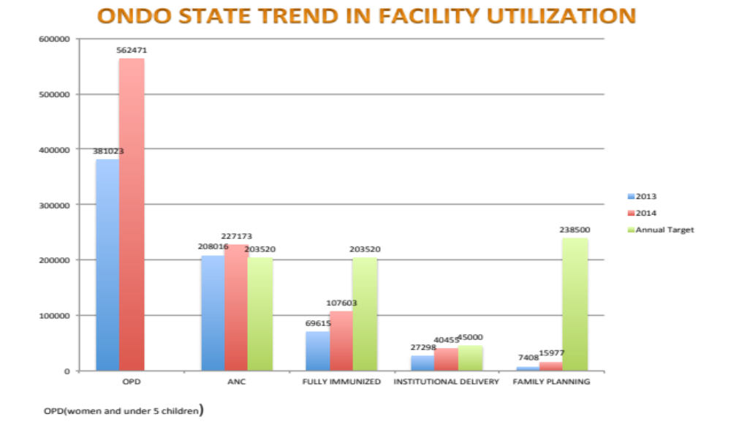
Figure 2: Trend of some key indicators of maternal & child health for years 2013 & 2014

Source: DHIS 2.0 report for Ondo State

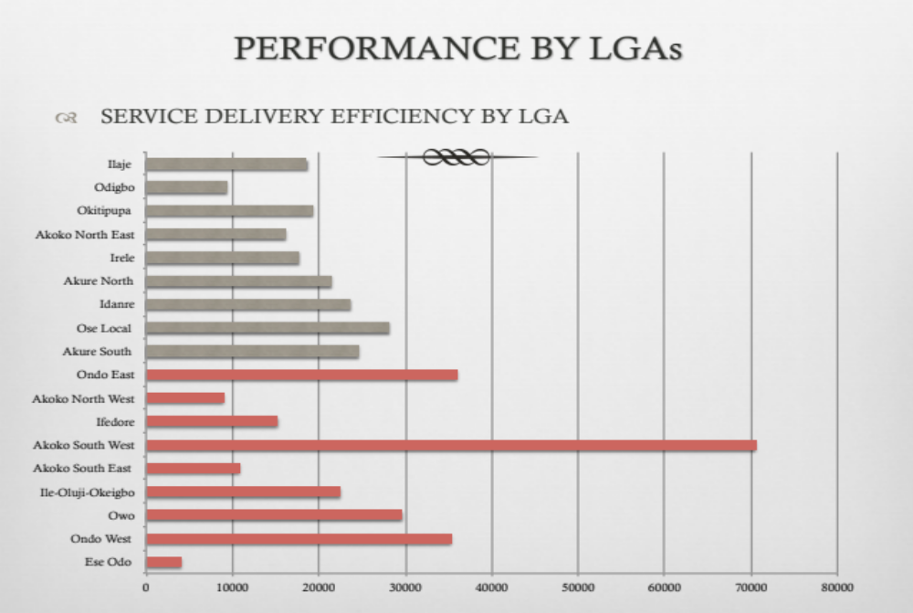
Figure 3: 2014 performance of LGAs using service output against population per 100,000
Source: DHIS 2.0 report for Ondo State

Figure 4: Maternal death profile of the State
Source: CEMDOS, 2015
Sources of fund
 | 2003 | 2004 | 2005
 | 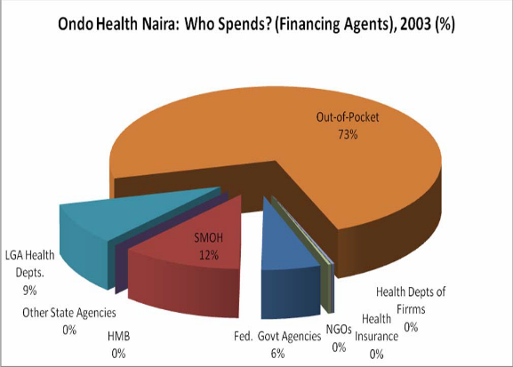 | 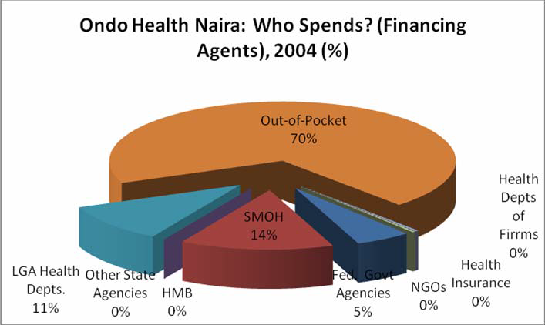 | 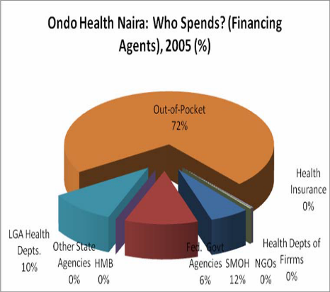
Provider Of services  Provider Of services | 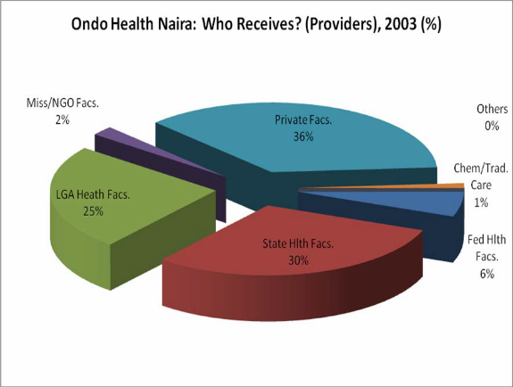 | 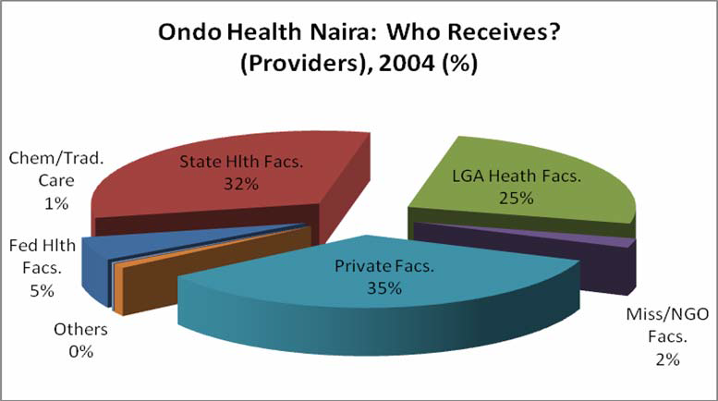 | 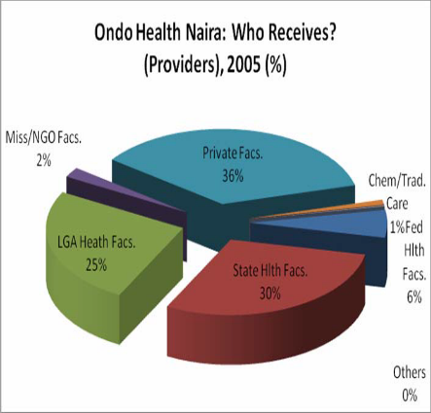
Expenditure Items | 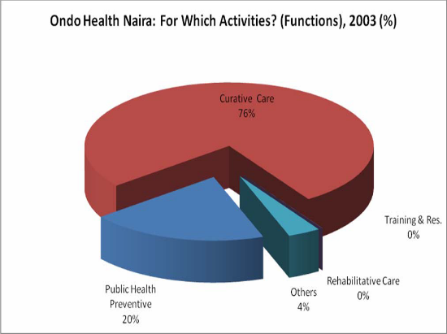 | 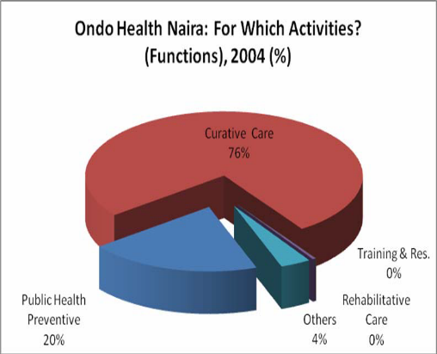 | 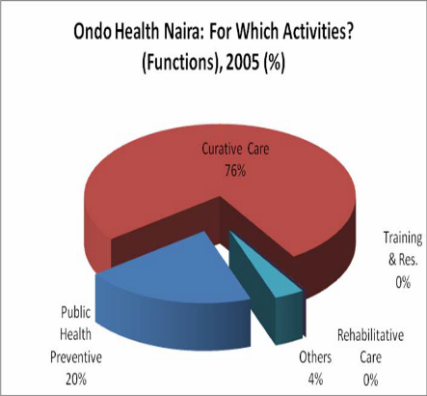
 | Source: National Health Account 2003-2005
 | NB: NHA 2006-2009(not disaggregated
Figure 5: Trend in Ondo State Total Health expenditure

Despite the improvement in healthcare service delivery in Ondo State, it is also faced with some challenges which are enumerated below:
- Inadequate Budgetary allocation for Health, which is below the 15% Abuja Declaration by the African heads of government in April, 2001.
- Difficult terrains/hard to reach communities constitute almost 33% of total settlements in the state,
- Inadequate human resource for health
- Unpredictable alternative funding source for health

- Extensive Government involvement in market pricing for health

  - Overview of the sector’s institutional structure
The Health sector is one of the cardinal and pivotal sectors of the state government and has the responsibility of providing policy direction for the health system development. It is an essential area of social service delivery to the populace. The sector comprises the Ministry of Health, 4 Agencies and 3 training schools.
(a) The Ministry comprises of the following departments:
- Planning Research & Statistics,
- Hospital Services,
- Public Health,
- Nursing Services,
- Pharmaceutical services, and
- Finance & Administration and Accounts.

(b) The agencies that are responsible for the execution of specific elements of the sector's projects and programmes in the State are:
- Hospitals Management Board
- Primary Health Care Development Board
- Ondo State Agency for the Control of AIDS
- Emergency Medical Services
- The training Institutions: Schools of Nursing and Midwifery are within the purview of the Department of Nursing Services while the School of Health Technology is under the Department of Public Health.
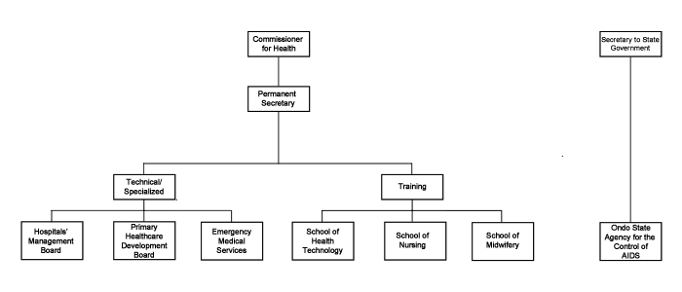
Figure 6: Organogram of the Health Sector

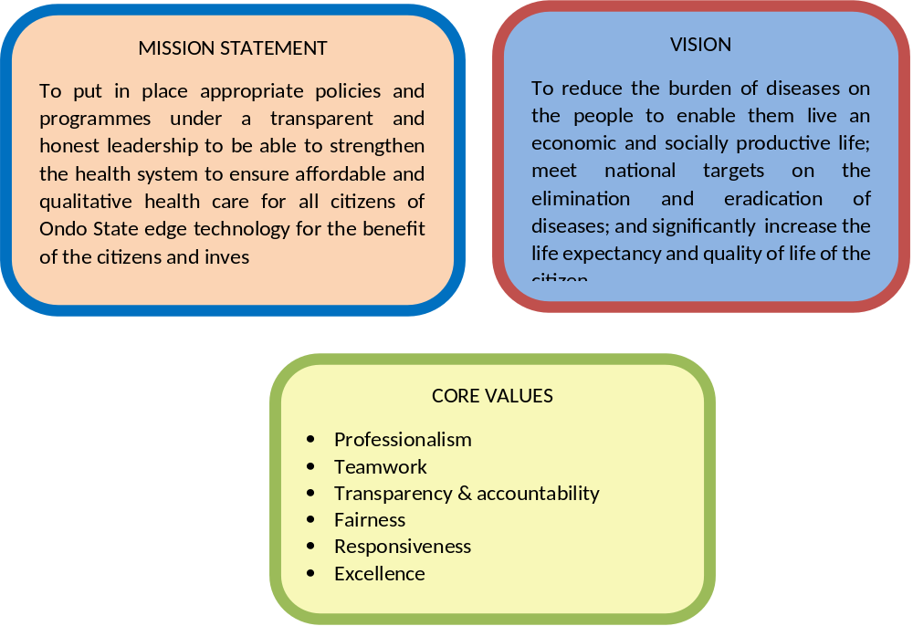
  - Statement of the sector’s mission, vision and core values

Table 2: Operational Definition of Sector's Core Values
Core Value | Definition | Examples of Behaviour | Strategy Implications
Professionalism | Professional excellence through prompt innovative, responsive and efficient service delivery  Exhibiting expertise, quality and professional ethics in the discharge of assigned duties. | - Skillfulness, competence and proficiency.  - Attention to details in all dealings.  - Constant strive for optimum effectiveness and efficiency.  - Quality service delivery | - Capacity building and effective training.  - Provision of relevant and quality working tools as well as conducive work environment.  - Effective manpower deployment (i.e. allocating appropriate personnel to jobs).  - Effectively apply a results-based performance evaluation system.
Teamwork | The act of a group of people working effectively and efficiently together towards a common goal through collaboration, information sharing and productive interactions.  Teamwork promotes synergy which enhances productivity. | - Collaboration and cooperation.  - Spontaneous sharing of information and best practices  - Productive interaction of members of a team to achieve common end.  - Interconnectedness.  - Interdependence.  - Mutual respect. | - Promote teamwork in the Health Sector through appropriate application of a reward and sanction system.  - Entrench teamwork as part of the staff code of conduct booklet.  - Open door policy to encourage information sharing  - Encouraging group tasks as against individual tasks.
Transparency & Accountability | Accountable and open in all activities.  As an organization that is critically dependent on taxpayers’ money, integrity is essential in the management of the resources entrusted to us. | - Open door policy to encourage openness and transparency.  - Frankness in a constructive manner in dealing with others.  - Honesty in all dealings with everyone.  - Doing what you say and saying what you mean and feel.  - Transparency and openness | - Institute best management practices and systems in the Health Sector (financial, HR, facilities) to facilitate the demonstration of integrity.  - Demonstrate zero tolerance to lapses relating to lack of integrity on the part of any member of staff through appropriate use of rewards and sanctions in relation to integrity.
Fairness | Ensuring Gender Equity (i.e. being fair to women and men according to their respective needs); and Gender Equality (i.e. equally valuing the similarities and differences of men and women, and the roles they play as partners in their homes, communities and societies)  Practical demonstration of gender equity and equality manifests in equality under the law, equal opportunity and equal access to human, financial and other productive resources | - Accountability to all constituent parts of Ondo State’s population.  - Ensuring equity and equality in the treatment of men and women in service delivery in the Health sector. | - Explicitly publicize that Ondo State Health Sector is an equal opportunity organization and act accordingly always.  - Avoid discrimination in service delivery to men and women.
Responsiveness | Responsive to our environment and technologically driven | - Reacting quickly and in a positive manner  - Reacting with interest and enthusiasm | - Organization have to be responsive to citizens needs
Source: Ministry of Health

  - Sector Policy
The aim of the State is to reduce the burden of diseases on the people to enable them live an economic and socially productive life; meet national targets on the elimination and eradication of diseases; and significantly increase the life expectancy and quality of life of the citizen.
Specifically, the review provided bases for the following elements of the MTSS:
- Goals and programmes setting;
- Projects specification;
- Key performance measures; and
- Targets, Outputs and Outcomes.

  - The sector’s goals and programmes for the MTSS period
This section presents brief description of the respective goals and programmes of Health sector. These will be done under the 8 Thematic strategic priority areas itemized below.
- Leadership & Governance
- Health Service Delivery
- Human Resources for Health
- Financing for Health
- Health Information System
- Community Participation
- Partnerships for Health
- Research for Health

Table 3: Summary of State Level Goals, Sector Level Goals, Programmes and Outcomes
State Level Goal | Sector Level Goal | Programme | Outcome
To reduce the burden of diseases on the people to enable them live an economic and socially productive life; meet national targets on the elimination and eradication of diseases; and significantly increase the life expectancy and quality of life of the citizen. | GOAL 1: To create and sustain an enabling environment for the delivery of quality health care and development in Ondo State | Health Policy planning | Improved policy direction for the health development
 |  | Health legislation and regulation | Strengthened Legislative and Regulatory Functions of Government for Health Development
 |  | Accountability, transparency and responsiveness of the health system | Strengthened accountability, transparency and responsiveness of the State health system
 |  | State health system performance  improvement | Improved the performance of the State Health System implemented by the State health sector
 | GOAL 2: To revitalize integrated  service delivery towards a  quality, equitable and sustainable healthcare | Universal access to essential package of care | Ensured universal access to an essential package of care
 |  | Access to health care services | Increased access to health care services
 |  | Quality of health care services | Improved the quality of health care service
 |  | Demand for health care services | Increased demand for health care services
 |  | Financial access for vulnerable groups | Provided financial access especially for the vulnerable groups
 | GOAL 3: To plan and implement strategies to address the human resources for health needs in order to enhance its  availability as well as ensure equity and quality of health care | Comprehensive policies and plans for HRH for health development | Formulated comprehensive policies and plans for HRH for health development
 |  | Framework for objective analysis,  implementation and monitoring of  HRH performance | Provided a framework for objective analysis, implementation and monitoring of HRH performance
 |  | Institutional framework for human  resources management practices (in the health sector) | Strengthened institutional framework for human resources management practices in the health sector
 |  | Capacity of training institutions to  scale up the production of a critical mass of quality, multipurpose,  multi-skilled, gender sensitive and  mid-level health workers | Strengthened the capacity of training institutions to scale up the production of a critical mass of quality, multipurpose, multi skilled, gender sensitive and mid-level health workers
 |  | Organizational and performance based systems for HRH | Improved organizational and performance based management systems for human resources for  health
 |  | Partnerships and networks to harness contributions for HRH agenda | Fostered partnerships and networks of stakeholders to harness contributions  for human resource for health agenda
 | GOAL 4: To ensure that adequate and sustainable funds are available and allocated for accessible,  affordable, efficient and equitable health care provision and consumption at local and State levels | Implementing Health Financing strategies | Improved Health financing strategies implemented at State and Local levels  consistent with the State Health Financing Policy
 |  | Protection from medical financial  catastrophe and impoverishment | Protection of people from financial catastrophe and impoverishment as a result of using health services
 |  | Sustainable funding of healthcare goals and objectives at all levels | Secured level of funding needed to achieve desired health development goals and objectives at all levels in a  sustainable manner
 |  | Efficiency and equity in the allocation  and use of health sector resources at  all levels | Efficient and equitable allocation and use of health sector resources at all levels
 | GOAL 5: To contribute to an effective National Health  Management Information System (NHMIS) to be used as a  management tool for informed  decision making at all levels for  improved health care | Data collection and transmission | Improved data collection and  transmission
 |  | Infrastructure support and ICT for health databases | Provision of infrastructural support and  ICT of health databases and staff training
 |  | Sub-Systems in Health Information  System | Strengthened sub-systems in the Health Information System
 |  | NHMIS Monitoring and Evaluation | Good monitoring and Evaluation of the NHMIS
 |  | Health Information Data Analysis and  Dissemination | Strengthened analysis of data and  dissemination of health information
 | GOAL 6: To attain effective  community participation in health development and  management, as well as  community ownership of  sustainable health outcomes | Community participation in health  development | Strengthened community participation in health development
 |  | Community ”ownership” of health  services | Empowered communities with skills for positive health actions
 |  | Community health services linkages | Strengthened community - health services linkages
 | GOAL 7: To enhance harmonized implementation of essential health services in line  with national health policy goals | Introduction of collaborative mechanisms for involving all partners in the development and sustenance of the health sector | Collaborative mechanisms are put in place for involving all partners in the development and sustenance of the health sector
 | GOAL 8: To utilize research to  inform policy, programming,  improve health, achieve  nationally and internationally health related development goals and contribute to the global knowledge platform | Research and knowledge management systems at all levels of  government | Strengthened stewardship role of governments at all levels for research and knowledge management systems
 |  | Institutional capacities to promote,  undertake and utilize research for evidence— based policy making in health at all levels | Institutional capacities to promote, undertake and utilise research for evidence based policy making in health at all levels strengthened
 |  | Comprehensive repository for health  research at all levels (including public and non-public sectors | Developed comprehensive repository for health research at all levels (including both public and non-public sectors)

Table 4: Goals, programmes and outcome deliverables
 | Goal | Programme | Outcome Deliverable | Performance indicator | baseline | Annual Actual | Mid-Team Target | Terminal Target
 |  |  |  |  | 2015 | 2017 | 2018 | 2019
 | PRIORITY AREA 1: LEADERSHIP AND GOVERNANCE FOR HEALTH
 | GOAL 1: To  create and  sustain an  enabling  environment  for the  delivery of  quality health  care and  development  in Ondo State | Health Policy planning | Improved policy direction for the health development | Percentage of stakeholders in Ondo State Health sector that are informed regarding the health development policy directives and whose programmes are derived from the  SSHDP | 50% | 60% | 70% | 75%
 |  | Health legislation and regulation | Strengthened Legislative and Regulatory Functions of Government for Health  Development | Percentage of health service providers that are operating  within their respective regulatory  health laws | 50% | 60% | 70% | 80%
 |  | Accountability, transparency and responsiveness of the health system | To strengthen accountability, transparency and responsiveness of the State  health system | % of annual facility utilization
 |  | State  health system  performance  improvement | To improve the performance  of the State Health System implemented by the State health sector | % of recommendations from  annual programme reviews | 0%
 | PRIORITY AREA 2: HEALTH SERVICES DELIVERY
 | GOAL 2: To  revitalize  integrated  service  delivery  towards a  quality,  equitable and  sustainable  healthcare | Universal  access to  essential  package of  care | To ensure universal access to an essential package of care | Percentage of wards with a functional PHC facility  providing minimum essential health care package |  | 80% | 90% | 100%
 |  | Access to  health care  services | To increase access to health care services | % of the population within  30mins walk or 5km of a health  service
 |  | Quality of  health care  services | To improve the quality of health care service | Proportion of registered TB cases cured under DOTS |  | 69.00% | 75.00% | 80.00%
 |  | Demand  for health care  services | To  increase  demand for  health care  services | Annual total outpatient attendance  in secondary and tertiary health facilities in the State (5% annual  increase)
 |  | Financial  access for  vulnerable groups | To provide financial access  especially for the vulnerable  groups | % of identified vulnerable people  given access to health services  free of charge | TBD | TBD | 100% | 100%
 | Priority Area 3: HUMAN RESOURCES FOR HEALTH
 | GOAL 3: To  plan and  implement  strategies to  address the  human  resources for  health needs  in order to  enhance its  availability as  well as ensure  equity and  quality of  health care | Comprehensive  policies and  plans for HRH  for health  development | To formulate comprehensive policies and plans for HRH  for health development | Ratio of Health Professionals per  population |  | TBD
 |  | Framework for  objective  analysis,  implementation  and  monitoring of  HRH  performance | To provide a framework for  objective analysis, implementation and  monitoring of HRH  performance | % of all Department & Agencies utilizing a standardized monitoring tool for HRH performance | 0% | 0% | 100% | 100%
 |  | Institutional  framework for  human  resources  management  practices (in  the health  sector) | Strengthen the institutional framework for human resources management practices in the health sector | % of State health facilities with  recommended HRH complement as per service delivery demands | TBD
 |  | Capacity of  training  institutions to  scale up the  production of  a critical mass of quality,  multipurpose,  multi-skilled,  gender  sensitive and  mid-level  health  workers | To strengthen the capacity of  training institutions to scale up the production of a critical mass of quality, multipurpose,  multi skilled, gender sensitive and mid-level health workers | No. of Mid-level health workers  trained per Health training institution per year | TBD
 |  | Organizational  and  performance based  systems  for HRH | To improve organizational  and performance based  management systems for  human resources for  health | % of Departments and Agencies  that have implemented performance-based management systems |  | 100% | 100% | 100%
 |  | Partnerships  and networks  to harness  contributions  for HRH  agenda | To foster partnerships and networks of stakeholders  to harness contributions  for human resource for  health agenda
 | Priority Area 4: FINANCING FOR HEALTH
 | GOAL 4: To  ensure that  adequate and  sustainable  funds are  available and  allocated for  accessible,  affordable, efficient and equitable health care provision and consumption at local and State levels | Implementing Health  Financing strategies | Improve Health financing  strategies implemented  at State and Local levels  consistent with the State Health Financing Policy | % of the State’s budget allocated to the Health Sector. | 3.20% | 7.00% | 12% | 15%
 |  | Protection  from medical  financial  catastrophe  and  impoverishment | To ensure that people  are protected from financial  catastrophe and impoverishment  as a result of using health  services | % of Ondo State Indigenes covered by any financial protection mechanism | TBD
 |  | Sustainable  funding of  healthcare  goals and  objectives at  all levels | To secure a level of funding  needed to achieve desired health development goals and  objectives at all levels in a  sustainable manner | % of total required/needed funds actually allocated to  Health at State level is increased by 10% yearly | TBD
 |  | Efficiency  and equity in  the allocation  and use of  health sector  resources at  all levels | To ensure  efficiency and  equity in the  allocation and  use of health  sector  resources at  all levels | Health Budget performance at the State level is improved | 38% | 40% | 50% | 60%
 | Priority Area 5: NATIONAL HEALTH INFORMATION SYSTEM
 | GOAL 5: To  contribute to  an effective  National  Health  Management  Information System  (NHMIS) to be  used as a  management  tool for  informed  decision making  at all  levels for  improved  health care | Data  collection and  transmission | To  improve data  collection and  transmission | Percentage of health facilities making routine ,timely and complete monthly NHMIS returns to the State level
 |  | Infrastructure  support and  ICT for health  databases | To  provide  infrastructural  support and  ICT of health  databases and  staff training | Proportion  of LGAs  using  customized  data  management software  (DHIS) | 0%
 |  | Sub-  Systems in  Health  Information  System | To  strengthen  sub-systems in  the Health  Information  System | Availability  Annual  HMIS Data  Audit  Review  Report | none
 |  | NHMIS  Monitoring  and Evaluation | To  monitor and  evaluate the  NHMIS | % of  programmes due for outcome/impact  evaluation  that had  evaluation  conducted  using  NHMIS data | 0%
 |  | Health  Information  Data Analysis  and  Dissemination | To  strengthen  analysis of  data and  dissemination  of health  information | Department  s and  Agencies  that  disseminate  statistical  progress  reports  periodically | TBD
 | Priority Area 6: COMMUNITY PARTICIPATION AND OWNERSHIP
 | GOAL 6: To attain  effective  community  participation  in health  development  and  management,  as well as  community  ownership of  sustainable  health  outcomes | Community  participation  in health  development | To  strengthen  community  participation  in health  development | Number of  quarterly/annual State  level fora to  engage  community  leaders and CBOs
 |  | Community  ”ownership”  of health  services | To  empower  communities  with skills for  positive health  actions | % of  CSOs and  community  leaders  trained and  engaging  with the  government  health  system | 0% |  | 5% | 20%
 |  | Community  health services  linkages | To  strengthen the  community -  health services  linkages | % of  public  health  facilities  that have  active  Committees  that include  community  representatives
 | Priority Area 7: PARTNERSHIPS FOR HEALTH
 | GOAL 7: To  enhance  harmonized  implementation  of essential  health  services in line  with national  health policy goals | Introduction  of  collaborative  mechanisms  for involving  all partners in  the  development  and  sustenance of  the health  sector | To ensure  that  collaborative  mechanisms  are put in  place for  involving all  partners in the  development  and  sustenance of  the health  sector | Existence of  a joint /  integrated  operational  work plan | none |  | yes | Yes
 | Priority Area 8: RESEARCH FOR HEALTH
 | GOAL 8: To  utilize  research to  inform policy,  programming,  improve  health,  achieve  nationally and  internationally  health related  development  goals and  contribute to  the global  knowledge  platform | Research  and  knowledge  management  systems at all  levels of  government | To  strengthen the  stewardship  role of  governments  at all levels for  research and  knowledge  management  systems | % of health budget spent on health research and evaluation at State Level | TBD
 |  | Institutional  capacities to  promote,  undertake and  utilize  research for  evidence—  based policy  making in  health at all  levels | To build  institutional  capacities to  promote,  undertake and  utilize  research for  evidence based  policy  making in  health at all  levels | Percentage of government policies and plans that are produced based on results of research and evaluation conducted | 0 | 0% | 20% | 30%
 |  | Comprehensive  repository  for health  research at all  levels  (including  public and  non-public  sectors | To develop a  comprehensive  repository  for health  research at all  levels  (including  both public  and nonpublic  sectors): | % of State Department and Agencies implementing the National Health Research communication Strategy

- The Development of Sector Strategy
  - Major Strategic Challenges
Some of the challenges encountered during the development of health sector’s strategy are:
- non availability and poor quality of relevant data;
- limited involvement of other relevant stakeholders;
- inadequate logistics provision;
- poor time management;
- insufficient cohesive system reasoning
  - Resource Constraints
Resource constraints are notable inhibitory factors to the capacity of the sector to implement its financial obligations. The actual budgetary release, as a percentage of the budgetary allocation to the health sector, reflects the resource constraints.
The following are the highlights of the 2015 budget data presented in table 6. The challenges encountered in implementing the 2015 budget are as listed below:
- Drastic reduction in the budget of MDAs e,g (sectoral budget comparison for 2014 and 2015 )
- Reduction in the federal allocation due to fall in price of crude oil in the international market
- Non availability of funds as at when needed

Table 5: Summary of 2014 Budget Data for the Sector
Item | Approved Budget (N) in 2014 | Amount Released (N) in 2014 | Actual Expenditure (N) in 2014 | Amount Released as % of Approved | Actual Expenditure as % of Releases
Personnel | 8,552,170,632.28 | 7,500,417,926.58 | 7,500,417,926.58 | 87.7% | 100%
Overhead | 110,700,000.00 | 45,987,500.00 | 45,987,500.00 | 41.50% | 100%
Capital | 7,112,464,000.00 | 1,811,307,836.52 | 1,811,307,836.52 | 25.50% | 100%
Total | 15,775,334,632.28 | 9,357,713,263.10 | 9,357,713,263.10 | 59.3% | 100%

Table 6: Summary of 2015 Budget Data for the Sector

Item | Approved Budget (N) in 2015 | Amount Released (N) in 2015 | Actual Expenditure (N) in 2015 | Amount Released as % of Approved | Actual Expenditure as % of Releases
Personnel | 9,048,342,518.69 | 7,430,933,327.13 | 7,430,933,327.13 | 82.1% | 100%
Overhead | 90,300,000.00 | 61,392,900.00 | 61,392,900.00 | 68.0% | 100%
Capital | 3,575,000,000.00 | 1,484,339,345.50 | 1,484,339,345.50 | 41.5% | 100%
Total | 12,713,642,518.69 | 1,976,000,345.37 | 1,976,000,345.37 | 17.2% | 100%

Table 7: Summary of 2016 Budget Data for the Sector (Jan-April/May 2016)
Item | Approved Budget (N) in 2016 | Amount Released (N) as at end April 2016 | Actual Expenditure (N) as at end April 2016 | Amount Released as % of Approved | Actual Expenditure as % of Releases
Personnel | 8,840,536,540.11 | 2,750,091,160.33 | 2,750,091,160.33 | 31.10% | 31.10%
Overhead | 57,500,000.00 | 22,100,000.00 | 22,100,000.00 | 38.44% | 38.44%
Capital | 5,002,200,000.00 | 936,385,140.90 | 936,385,140.90 | 18.7% | 18.7%
Total | 13,900,236,540.11 | 3,708,576,301.23 | 3,708,576,301.23 | 26.68% | 26.68%

Table 8: Summary of the Review of Ongoing and Existing Projects Scorecard (Ranked by Average score for Ongoing and Existing Projects and by Final Score for New Projects)
S/N | Project Title | Criterion 1 | Criterion 2 | Criterion 3 | Criterion 4 | Criterion 5 | Average / Final Score | Rank | Justification
Ongoing Projects
1 | Care and Support of People Infected and Affected by HIV/AIDS | 4 | 4 | 4 | 4 | 4 | 4 | 1 | Poor socio-economic impact indices as a result of poor home based care
2 | Coordination meeting platforms( SACA-LACA, SACA-CSO, SACA-LM, Biannual meeting) | 4 | 4 | 4 | 4 | 4 | 4 | 1 | Weak coordination at various levels.
3 | Medical Assistance to Federal Medical Centre ,Owo | 4 | 4 | 4 | 4 | 3 | 3.8 | 3
4 | HIV Counseling and Testing | 4 | 4 | 3 | 4 | 4 | 3.8 | 3 | Inadequate HCT sites especially at the rural area & Low uptake of HCT
5 | Condom Promotion | 4 | 4 | 4 | 4 | 3 | 3.8 | 3 | Required for supply of condoms to employees at government, industrial offices & Required for MPPI for outreaches in the state
6 | Women and men in need of HIV treatment receive treatment | 4 | 4 | 4 | 4 | 3 | 3.8 | 3 | Positive pregnant women are lost to TBAs. Low knowledge on PMTCT. Low condom use.
7 | Construction of Hostels for Schools of Nursing | 4 | 4 | 4 | 4 | 3 | 3.8 | 3 | To meet up with the Requirement of N&MCN for Accreditation of the School
8 | Payment of Allowance for Guest Lecturers (SoN) | 4 | 4 | 4 | 4 | 3 | 3.8 | 3 | Enhances Students’ Knowledge & Skills in different Specialties of Practice
9 | Library (Journals) | 4 | 4 | 4 | 4 | 3 | 3.8 | 3 | Updating of Students Knowledge on New trends
10 | Provision of Office Furniture & Internet Services for SON | 4 | 4 | 4 | 4 | 3 | 3.8 | 3 | Conducive Working Environment for Teachers & Availability of Internet for Students
11 | Accreditation exercises for School of health Tech | 4 | 4 | 4 | 4 | 3 | 3.8 | 3 | Prerequisite for admission of new students
12 | External works at Mother and Child Hospital, Ondo (Completed but not paid) | 4 | 4 | 3 | 4 | 3 | 3.6 | 12
13 | Construction of Medical Ward at Trauma and Surgical Centre Ondo | 4 | 4 | 4 | 3 | 3 | 3.6 | 12 | For a comprehensive management of medical cases as a prerequisite for accreditation as Teaching Hospital
14 | Upgrading of Comprehensive Health Centre, Araromi-Obu to General Hospital | 4 | 4 | 3 | 4 | 3 | 3.6 | 12 | To increase accessibility and referral services
15 | Construction of Science Laboratory for the Schools of Nursing and Midwifery | 4 | 4 | 3 | 4 | 3 | 3.6 | 12 | To meet up with the Requirement of N&MCN for Accreditation of the School
16 | Trauma and surgical Centre | 4 | 4 | 4 | 3 | 3 | 3.6 | 12 | To cope with influx of referrals
17 | Task force on Counterfeit and Fake drugs | 4 | 4 | 4 | 2 | 4 | 3.6 | 12 | To reduce circulation of counterfeit drugs
18 | Nursing and Midwifery Council of Nigeria Activities | 4 | 4 | 4 | 2 | 4 | 3.6 | 12 | Monitoring and evaluation
19 | Emergency Preparedness and Disease Surveillance | 4 | 4 | 4 | 2 | 4 | 3.6 | 12 | To improve the state capacity to manage emerging disease outbreak
20 | Facility based Records (Data Mop-up) | 4 | 4 | 4 | 2 | 4 | 3.6 | 12 | To strengthen data management
21 | Confidential Enquiry into Maternal Death | 4 | 4 | 4 | 2 | 4 | 3.6 | 12 | To track the causes of maternal death and improve response
22 | Nigeria State Health Investment Project Credit (World Bank Assisted) | 4 | 4 | 4 | 3 | 3 | 3.6 | 12 | To improve quantity and quality of health service delivery
23 | Printing of Health Management Information System data tools | 4 | 3 | 4 | 3 | 4 | 3.6 | 12 | To ensure effective data management
24 | Community Medicine | 4 | 4 | 4 | 2 | 4 | 3.6 | 12 | To enhance public health activities
25 | Communications | 3 | 4 | 4 | 4 | 3 | 3.6 | 12 | Behavior change communication out of stock & Poor comprehensive knowledge of HIV/AIDS
26 | Prevention of Biomedical Transmission of HIV | 4 | 4 | 3 | 4 | 3 | 3.6 | 12 | Positive pregnant women are lost to TBAs. Low knowledge on PMTCT. Low condom use.
27 | Policy, Advocacy, Human Rights, and Legal Issues | 4 | 4 | 3 | 4 | 3 | 3.6 | 12 | There is no anti-stigma law (anti-stigma law it has passed second reading in the state house of assembly).
28 | Human resources (capacity building) | 4 | 4 | 3 | 4 | 3 | 3.6 | 12 | Some staff have retired. New and old staff should be trained on current updates.
29 | Financial Resources | 4 | 4 | 3 | 4 | 3 | 3.6 | 12 | Irregular release of fund to LACAs & MDAs for HIV activities.
30 | Monitoring and Evaluation, Research and Knowledge Management | 4 | 4 | 4 | 3 | 3 | 3.6 | 12 | There is need for regular capacity building for data collection and report of activities been carried out
31 | Accreditation of School of Midwifery and other activities of N&MCN | 4 | 4 | 2 | 4 | 4 | 3.6 | 12 | To lift embergo on students admission
32 | Completion of Modern Laboratory | 4 | 4 | 3 | 4 | 3 | 3.6 | 12 | Enhances Better Practical experienceStudents
33 | Procurement of Reagents/Consumables | 4 | 4 | 3 | 4 | 3 | 3.6 | 12 | Enhances Better Practical experience Students
34 | Procurement of laboratory Chemicals, reagents& consumables School of health Tech | 4 | 4 | 3 | 4 | 3 | 3.6 | 12 | Enhances Better Practical experience Students
35 | Additional jobs on the construction of Accident and Emergency Hospital Complex at Trauma Centre Ondo | 3 | 4 | 3 | 4 | 3 | 3.4 | 35 | To cope with influx of referrals
36 | Festival of Surgery; Eye Camp at the MEC | 4 | 4 | 4 | 2 | 3 | 3.4 | 35 | To assist the indigent patients
37 | Medical Board of Enquiry and Medical Assistance | 4 | 4 | 4 | 2 | 3 | 3.4 | 35 | For medical evaluation and requisite medical assistance
38 | Activities of the Medical and Dental Council of Nigeria | 4 | 4 | 4 | 2 | 3 | 3.4 | 35 | To maintain standard of practice and ethics
39 | HIV/AIDS Prevention and control/rehabilitation programme for people living with HIV/AIDS | 4 | 4 | 3 | 2 | 4 | 3.4 | 35 | To reduce incidence and improve treatment and care of HIV/AIDS cases
40 | Inspection of Pharmaceutical premises and patient Medicine shops | 4 | 4 | 4 | 2 | 3 | 3.4 | 35 | To maintain standard of practice and ethics
41 | Pharmacists Council of Nig. Activities | 4 | 4 | 4 | 2 | 3 | 3.4 | 35 | To regulate Pharmaceutical practice
42 | Monitoring and Evaluation of Nursing Services | 4 | 4 | 4 | 2 | 3 | 3.4 | 35 | To regulate standard of practice
43 | Nigeria State Health Investment Programme DLI Re-imbursement | 4 | 4 | 4 | 2 | 3 | 3.4 | 35 | To enhance effective service delivery
44 | Provision for 1 year mandatory community experience for 50 basic students midwives for maternal & child care | 4 | 4 | 4 | 2 | 3 | 3.4 | 35 | To improve maternal and child care
45 | Neonatal Intensive Nursing Training Programme | 4 | 4 | 4 | 2 | 3 | 3.4 | 35 | To improve Neonatal service
46 | Free Health Drugs | 4 | 4 | 4 | 2 | 3 | 3.4 | 35 | To enhance drug accessibility
47 | Ondo State Health Statistics bulletin | 4 | 4 | 4 | 2 | 3 | 3.4 | 35 | For information dissemination
48 | Meetings of State/ National Council on Health | 4 | 4 | 4 | 2 | 3 | 3.4 | 35 | For holistic health care policy formulation
49 | Accreditation Visit N and MC | 4 | 4 | 4 | 2 | 3 | 3.4 | 35 | To lift embargo on students admission
50 | Safe motherhood project-scaling up of Abiye | 4 | 4 | 4 | 2 | 3 | 3.4 | 35 | To improve maternal and child health
51 | National Council on Health | 4 | 4 | 4 | 2 | 3 | 3.4 | 35 | For holistic health care policy formulation
52 | Prevention of Mother to Child Transmission of HIV(PMTCT) | 3 | 4 | 3 | 4 | 3 | 3.4 | 35 | Inadequate HCT sites, & Low uptake of PMTCT especially at the rural area
53 | Construction of hostels for School of Nursing and Midwifery | 4 | 4 | 3 | 3 | 3 | 3.4 | 35 | To meet up with the Requirement of N&MCN for Accreditation of the School
54 | Procurement of anatomical models for demonstration rooms of the school | 4 | 4 | 3 | 3 | 3 | 3.4 | 35 | To enhance teaching/learning process
55 | Management and Maintenance of Mother and Child Hospital and Other Health Facilities | 4 | 4 | 4 | 2 | 3 | 3.4 | 35 | To enhance service delivery
56 | Maintenance of inmate of Ago-Ireti | 4 | 4 | 4 | 2 | 3 | 3.4 | 35 | To assist the inmates
57 | Assistance towards Medical Treatment | 4 | 4 | 4 | 2 | 3 | 3.4 | 35 | To give support to indigents
58 | Landscaping and beautification of Laje Road Ondo (Access road to Medical Village) | 4 | 4 | 3 | 3 | 2 | 3.2 | 58 | To provide a conducive environment
59 | Construction of Surgical Ward extension and Physiotherapy Unit at Trauma Centre Ondo | 3 | 4 | 2 | 4 | 3 | 3.2 | 58 | To cope with influx of referrals
60 | Construction of Alaanu Hostel, Medical Village Ondo | 4 | 4 | 2 | 4 | 2 | 3.2 | 58 | To provide accommodation for patient relatives
61 | Accrediation and Registration of Private Health Facilities | 4 | 4 | 3 | 2 | 3 | 3.2 | 58 | To ensure provision of quality health care services
62 | Roll back malaria | 3 | 4 | 3 | 2 | 4 | 3.2 | 58 | For prevention and control of malarial infection
63 | TBL Control Programme | 4 | 4 | 2 | 2 | 4 | 3.2 | 58 | For prevention and control of TBL
64 | Non-communicable Diseases | 4 | 4 | 3 | 2 | 3 | 3.2 | 58 | For prevention and control of non-communicable diseases
65 | Publicity | 3 | 4 | 4 | 2 | 3 | 3.2 | 58 | Health promotion and awareness
66 | Staff Training | 4 | 4 | 2 | 2 | 4 | 3.2 | 58 | To enhance efficiency and effectiveness
67 | IGR Tracking | 4 | 4 | 3 | 2 | 3 | 3.2 | 58 | To monitor revenue generation
68 | Renovation of block 11 at GH, Idanre | 4 | 2 | 4 | 4 | 2 | 3.2 | 58 | To improve capacity to manage inpatient cases
69 | Health Education and Social Mobilisation | 4 | 3 | 4 | 2 | 3 | 3.2 | 58 | Health promotion and awareness and to enhance community participation
70 | Maternal, Newborn and Child Health week | 4 | 3 | 4 | 2 | 3 | 3.2 | 58 | To improve maternal, newborn and child health services
71 | Non-communicable diseases (Guinea worm) | 4 | 3 | 4 | 2 | 3 | 3.2 | 58 | For prevention and control of Guinea worm
72 | HIV/AIDS | 4 | 3 | 4 | 2 | 3 | 3.2 | 58 | To prevent and control HIV/AIDS
73 | Onchocerciasis | 4 | 3 | 4 | 2 | 3 | 3.2 | 58 | To prevent and control Onchocerciasis
76 | Midwifery service scheme/SURE-P | 4 | 3 | 4 | 2 | 3 | 3.2 | 58 | To improve maternal and child services
77 | Reproductive Health/Family Planning | 4 | 3 | 4 | 2 | 3 | 3.2 | 58 | To improve maternal health
78 | National programme for Immunization (ORIREWA) | 4 | 3 | 4 | 2 | 3 | 3.2 | 58 | To improve immunization services
80 | Schistosomiasis | 4 | 3 | 4 | 2 | 3 | 3.2 | 58 | To prevent and control Schistosomiasis
81 | Nutrition | 4 | 4 | 3 | 2 | 3 | 3.2 | 58 | To improve nutritional support services
82 | Institutional Arrangement and Coordination Mechanism | 4 | 4 | 2 | 4 | 2 | 3.2 | 58 | Irregular release of fund to LACAs & MDAs for Proper coordination of preventive activities
83 | Procurement & logistics supply | 4 | 4 | 2 | 4 | 2 | 3.2 | 58 | Stock out of commodities has affected uptake of HIV services.
84 | Basic Laboratory Equipment; and other Medical Equipment | 4 | 4 | 3 | 1 | 3 | 3 | 84 | To improve medical service
85 | Counterpart Fund (NHIS) | 2 | 4 | 3 | 3 | 3 | 3 | 84 | To provide support for health service delivery
86 | Printing of Free Health Cards | 4 | 4 | 3 | 2 | 2 | 3 | 84 | To provide free health service to under-5 children
87 | Purchase of office equipment | 4 | 4 | 3 | 2 | 2 | 3 | 84 | To improve health care administration
88 | Health Insurance for Primary School Pupils Counterpart Contribution | 3 | 4 | 3 | 2 | 3 | 3 | 84 | To provide support for health service delivery
90 | Renovation of existing facilities / Procurement of consumables (SoM) | 3 | 4 | 2 | 3 | 3 | 3 | 84 | To enhance learning
91 | Payment of allowance for guest lecturers (SoM) | 4 | 4 | 2 | 3 | 2 | 3 | 84 | Enhances Students’ Knowledge & Skills in different Specialties of Practice
92 | upgrading of facilities for the School of Nursing and Midwifery | 2 | 4 | 3 | 3 | 3 | 3 | 84 | Adds Aesthetic value to school environment
93 | Completion of Igbotako General Hospital | 4 | 4 | 2 | 1 | 3 | 2.8 | 93 | To improve service delivery
94 | Population Activities | 2 | 4 | 3 | 2 | 3 | 2.8 | 93 | For community mapping, planning and public health intervention
95 | Public Health Laboratory | 2 | 4 | 3 | 2 | 3 | 2.8 | 93 | To improve the diagnostic capacity for diseases of public health importance
96 | Renovation of children ward, SSHO | 4 | 2 | 2 | 4 | 2 | 2.8 | 93 | To improve inpatient care
97 | Health Rangers | 3 | 3 | 3 | 2 | 3 | 2.8 | 93 | To improve facility utilization
98 | School Health service | 3 | 3 | 3 | 2 | 3 | 2.8 | 93 | To provide school health services
99 | Updating of teachers by N&MCN | 4 | 4 | 2 | 2 | 2 | 2.8 | 93 | Capacity Building Towards Effective Service Delivery
100 | Procurement and equipment of the sick-bay | 4 | 4 | 2 | 2 | 2 | 2.8 | 93 | Prompt health care services to students
101 | Procurement of reagents/ consumables | 3 | 4 | 2 | 3 | 2 | 2.8 | 93 | Better Performance of Students in Practical Aspects
102 | Procurement of library books School of health Tech | 4 | 3 | 2 | 3 | 2 | 2.8 | 93 | Updating of Students Knowledge on New Trends
103 | Central Blood Transfusion Services | 3 | 4 | 1 | 2 | 3 | 2.6 | 103 | To promote safe blood transfusion
105 | International Travel Control Unit | 2 | 4 | 3 | 2 | 2 | 2.6 | 103 | To certify health status of intending travelers
106 | Construction and Expansion of Equipment Stores and Traditional Medicine Board Offices, Oke-Eda | 1 | 4 | 3 | 2 | 3 | 2.6 | 103 | To enhance medical equipment storage capacity and to regulate activities of traditional medical practitioners
107 | Integrated supportive supervision | 3 | 2 | 3 | 2 | 3 | 2.6 | 103 | For effective monitoring and evaluation of health service delivery.
108 | Security and cleaning of secretariat complex | 2 | 2 | 3 | 2 | 3 | 2.4 | 108 | For conducive administrative environment
109 | General services | 2 | 2 | 3 | 2 | 3 | 2.4 | 108 | For maintainnce
110 | Annual World Health Day | 3 | 2 | 3 | 2 | 2 | 2.4 | 108 | To create health awareness
111 | Monitoring/Quaterly Board Meetings/ Monthly Technical Review meetings | 3 | 2 | 3 | 2 | 2 | 2.4 | 108 | For effective coordination of health services.
113 | District Health Management Information System | 3 | 2 | 3 | 2 | 2 | 2.4 | 108 | To improve data quality and management.
115 | Procurement of Dental Chair for School of health Tech | 2 | 2 | 3 | 2 | 2 | 2.2 | 115 | To improve quality of training for dental service.
116 | Florence Nightingale Speech Contest | 2 | 1 | 2 | 2 | 3 | 2 | 116 | Stimulates Healthy Educational Interactions among the Students
117 | Provision of Sporting Facilities & NISONMG | 2 | 1 | 2 | 2 | 3 | 2 | 116 | Stimulates Sporting Interactions among all Students of Schools of Nursing in Nigeria
118 | Updating of Teachers by Nursing & Midwifery Council | 2 | 1 | 3 | 2 | 1 | 1.8 | 118 | Capacity Building Towards Effective Service Delivery
S/N |  | Project Title | Criterion 1 |  | Criterion 2 |  | Criterion 3 |  |  | Criterion 4 | Criterion 5 |  |  | Average / Final Score |  | Rank |  | Justification
New Projects
1 | 3 nos of incinerators |  |  | NA |  | NA |  | NA | NA |  |  | 4 | 4 |  | 1 |  | For health Service Delivery
2 | Maintenance and support of call centre, cost system, wide line, bandwith, subscription, Toll-Free lines |  |  | NA |  | NA |  | NA | NA |  |  | 4 | 4 |  | 1 |  | For prompt emergency surveillance and response
3 | Accreditation of SON |  |  | NA |  | NA |  | NA | NA |  |  | 4 | 4 |  | 1 |  | Lifting of embargo on students admission
4 | Re-Roofing of Classrooms (SoN) |  |  | NA |  | NA |  | NA | NA |  |  | 4 | 4 |  | 1 |  | Conducive learning environment for students
5 | Construction of Mother and Child Hospital, Ikare |  |  | NA |  | NA |  | NA | NA |  |  | 3 | 3 |  | 5 |  | To Increase coverage for maternal and child health Service
6 | Construction of Mother and Child Hospital, Okitipupa |  |  | NA |  | NA |  | NA | NA |  |  | 3 | 3 |  | 5 |  | To Increase coverage for maternal and child health Service
7 | Renovation and upgrading of Secondary Facilities |  |  | NA |  | NA |  | NA | NA |  |  | 3 | 3 |  | 5 |  | Improved Health Service Delivery
8 | Construction of Public Health Laboratory,OkeEda ,Akure |  |  | NA |  | NA |  | NA | NA |  |  | 3 | 3 |  | 5 |  | For improved health Service Delivery
9 | Logistics Management and Coordinating Unit (LMCU) |  |  | NA |  | NA |  | NA | NA |  |  | 3 | 3 |  | 5 |  | For improved health Service Delivery
10 | Health Insurance for Primary School Pupils |  |  | NA |  | NA |  | NA | NA |  |  | 3 | 3 |  | 5 |  | Health Service coverage and reducing out of pocket expenses for school pupils
11 | Procurement of one number public address system vehicle |  |  | NA |  | NA |  | NA | NA |  |  | 3 | 3 |  | 5 |  | For sensitization and awareness
12 | Construction of additional Base Station at Igbado |  |  | NA |  | NA |  | NA | NA |  |  | 3 | 3 |  | 5 |  | Improved coverage around the state
13 | EMS Vehicle Sticker Printing and Deployment |  |  | NA |  | NA |  | NA | NA |  |  | 3 | 3 |  | 5 |  | For publicity
14 | Supply of Ambulance, Extrication Vehicle and Towing Truck for the Igbado Base Station |  |  | NA |  | NA |  | NA | NA |  |  | 3 | 3 |  | 5 |  | For Improved emergency response system
15 | Computerized Web Based EMS Management System(Inventory Management System, Trauma Registry and Personnel Management System) |  |  | NA |  | NA |  | NA | NA |  |  | 3 | 3 |  | 5 |  | For Improved data compilation of human resources for health
16 | Construction of school clinic and school store (SoM) |  |  | NA |  | NA |  | NA | NA |  |  | 3 | 3 |  | 5 |  | For prompt Health Care service delivery to Students
17 | Construction of Sick-Bay for SON |  |  | NA |  | NA |  | NA | NA |  |  | 3 | 3 |  | 5 |  | For prompt Health Care delivery to Students
18 | Re-Roofing of Administrative Block (SoN) |  |  | NA |  | NA |  | NA | NA |  |  | 3 | 3 |  | 5 |  | Conducive working environment for staff
19 | Construction of Students Chairs and lockers School of health Tech |  |  | NA |  | NA |  | NA | NA |  |  | 3 | 3 |  | 5 |  | Conducive learning environment for staff
20 | Construction of New Administrative block School of health Tech |  |  | NA |  | NA |  | NA | NA |  |  | 3 | 3 |  | 5 |  | Conducive working environment for staff
21 | Purchase of 100 double bunk beds School of health Tech |  |  | NA |  | NA |  | NA | NA |  |  | 3 | 3 |  | 5 |  | To improve learning
22 | Teaching Aids for DST |  |  | NA |  | NA |  | NA | NA |  |  | 3 | 3 |  | 5 |  | To improve learning and skill acquisition
23 | Purchase of 3 Hilux Vehicles |  |  | NA |  | NA |  | NA | NA |  |  | 3 | 3 |  | 5 |  | For improved service delivery
24 | Construction / Provision of Office Buildings |  |  | NA |  | NA |  | NA | NA |  |  | 3 | 3 |  | 5 |  | For conducive environment for employee
25 | Rehabilitation / Repair of Office Buildings |  |  | NA |  | NA |  | NA | NA |  |  | 3 | 3 |  | 5 |  | Health Service Delivery
26 | Research and Development |  |  | NA |  | NA |  | NA | NA |  |  | 3 | 3 |  | 5 |  | To increase research in the state
27 | Capacity Building |  |  | NA |  | NA |  | NA | NA |  |  | 3 | 3 |  | 5 |  | Improved Human Resources for Health
28 | Establishment of Health Insurance Agency |  |  | NA |  | NA |  | NA | NA |  |  | 2 | 2 |  | 28 |  | To increase universal health coverage
29 | 3 nos of Hilux vehicle |  |  | NA |  | NA |  | NA | NA |  |  | 2 | 2 |  | 28 |  | For health Service Delivery
30 | 6 nos of ambulance vehicles |  |  | NA |  | NA |  | NA | NA |  |  | 2 | 2 |  | 28 |  | for emergency rescue of victims across the state
31 | Reconstruction of cold chain store Okitipupa |  |  | NA |  | NA |  | NA | NA |  |  | 2 | 2 |  | 28 |  | To increase the lifespan of vaccines for improved service delivery
32 | 18 nos of Ice liner deep freezers |  |  | NA |  | NA |  | NA | NA |  |  | 2 | 2 |  | 28 |  | To increase the lifespan of vaccines for improved service delivery
33 | Construction of Akure administrative office extension including office equipment and Furniture |  |  | NA |  | NA |  | NA | NA |  |  | 2 | 2 |  | 28 |  | Improved conducive environment
34 | Drilling of Bore Hole for five Base Station |  |  | NA |  | NA |  | NA | NA |  |  | 2 | 2 |  | 28 |  | For health Service Delivery
35 | Purchase of Library textbooks |  |  | NA |  | NA |  | NA | NA |  |  | 2 | 2 |  | 28 |  | Updating of Students Knowledge on New Trends
36 | Landscaping & Beautification of the SON & SOM |  |  | NA |  | NA |  | NA | NA |  |  | 2 | 2 |  | 28 |  | Aesthetic learning and working environment
37 | Construction of Matron's Quarters for SON |  |  | NA |  | NA |  | NA | NA |  |  | 2 | 2 |  | 28 |  | To meet up with the Requirement of N&MCN for Accreditation of the School
38 | Landscaping Beautification of School of health Tech |  |  | NA |  | NA |  | NA | NA |  |  | 2 | 2 |  | 28 |  | Aesthetic learning and working environment
39 | Resuscitation of X-Ray Department School of health Tech |  |  | NA |  | NA |  | NA | NA |  |  | 2 | 2 |  | 28 |  | To contribute more to hospital utilization
40 | Renovation Re-roofing of present administrative block School of health Tech |  |  | NA |  | NA |  | NA | NA |  |  | 2 | 2 |  | 28 |  | Conducive and cosy environment for staff
41 | Procurement of Office furniture School of health Tech |  |  | NA |  | NA |  | NA | NA |  |  | 2 | 2 |  | 28 |  | Conducive and cosy environment for staff
42 | Procurement of 1No 40-seater Bus School of health Tech |  |  | NA |  | NA |  | NA | NA |  |  | 2 | 2 |  | 28 |  | Transporting of students during engagement by the school
43 | Enlightenment / Awareness |  |  | NA |  | NA |  | NA | NA |  |  | 2 | 2 |  | 28 |  | Health Service Delivery
44 | 19 nos of backup generators |  |  | NA |  | NA |  | NA | NA |  |  | 1 | 1 |  | 44 |  | Health Service Delivery

Note:
NA = Not Applicable
Criterion 1= Evidence that the Existing Projects are indeed Ongoing
Criterion 2= Clarity of Current Justification for Budget Commitment
Criterion 3= Current Impact of Budget Commitment
Criterion 4= Likelihood of Completion in 2017 – 2019 Timeframe.
Criterion 5= Relation to the Sector’s goals

Table 9: Capital Costs Commitments
S/N | Project Title | Status of Completion | Contract Sum (N) | Amount Paid to Date (N) | Outstanding Commitment (N)
1. | Care and Support of People Infected and Affected by HIV/AIDS | Ongoing | 5,000,000
2. | Coordination meeting platforms( SACA-LACA, SACA-CSO, SACA-LM, Biannual meeting) | Ongoing | 8,000,000
3. | Medical Assistance to Federal Medical Centre, Owo | Ongoing | 10,000,000
4. | HIV Counseling and Testing | Ongoing | 14,000,000
5. | Condom Promotion | Ongoing | 6,500,000
6. | Women and men in need of HIV treatment receive treatment |  | 6,500,000
7. | Construction of Hostels for Schools of Nursing and Midwifery | Ongoing | 100,000,000.00 | 76,000,000 | 24,000,000.00
8. | Payment of Allowance for Guest Lecturers (SoN) | Ongoing | 1,650,000.00 | - | 1,650,000.00
9. | Library (Journals) | Ongoing | 950,000.00 | - | 950,000.00
10. | Provision of Office Furniture & Internet Services for SON | Ongoing | 1,200,000.00 | - | 1,200,000.00
11. | Accreditation exercises for School of health Tech |  | 10,000,000
12. | Base Station roomy (5 Base Stations and Call Centre) | Ongoing | 3,000,000
13. | Maintenance and Support of Call Centre Cost System wide line bandwidth, subscription, Toll free lines | Ongoing | 25,000,000
14. | Purchase of diesel for the Call Centre | Ongoing | 2,000,000
15. | External works at Mother and Child Hospital, Ondo (Completed but not paid) | Ongoing | 630,809,995.07 | 554,685,494.84 | 76,124,045.23
16. | Construction of Medical Ward at Trauma and Surgical Centre Ondo | Reviewed | 514,741,450.57 | 302,127,634.87 | 212,613,815.70
17. | Upgrading of Comprehensive Health Centre, Araromi-Obu to General Hospital
18. | Completion of Science Laboratory for the Schools of Nursing and Midwifery | Ongoing | 950,000.00 | 900,000.00 | 50,000.00
19. | Trauma and surgical centre |  | 2,500,000,000,000
20. | Task force on Counterfeit and Fake drugs |  | 1,000,000
21. | Nursing and Midwifery Council of Nigeria Activities |  | 1,000,000
22. | Emergency Preparedness and Disease Surveillance |  | 100,000,000
23. | Facility bases records (Data Mop-up) |  | 2,000,000
24. | Confidential Enquiry into Maternal Death |  | 3,500,000
25. | Nigeria State Health Investment Project Credit (World Bank Assisted) |  | 4,000,000
26. | Printing of Health Management Information System data tools
27. | Community Medicine |  | 250,000
28. | Commuincations (outreaches and special event) |  | 2,000,000
29. | Prevention of Biomedical Transmission of HIV |  | 6,750,000
30. | Policy, Advocacy, Human Rights, and Legal Issues |  | 2,000,000
31. | Human resources (capacity building) |  | 7,500,000
32. | Financial Resources |  | 2,000,000
33. | Monitoring and Evaluation, Research and Knowledge Management |  | 10,000,000
34. | Accreditation of School of Midwifery and other activities of N&MCN |  | 1,000,000 | 1,000,000 | -
35. | Completion of Modern Laboratory |  | 750,000
36. | Procurement of Reagents/Consumables | Ongoing | 950,000.00 | - | 950,000.00
37. | Procurement of laboratory Chemicals, reagents & consumables School of health Tech |  | 1,000,000
38. | Branding and EMS Social Awareness Campaign / Trauma Summit Publicity |  | 10,000,000
39. | Base Station fuel upkeep, EMS Consumables |  | 40,000,000
40. | Maintenance of Operational Vehicles (Ambulances, Towing Trucks, Extrication and Utility vehicles) |  | 45,000,000
41. | Additional jobs on the construction of Accident and Emergency Hospital Complex at Trauma Centre Ondo |  | -
42. | Festival of Surgery; Eye Camp at the MEC |  | 20,000,000
43. | Medical Board of Enquiry and Medical Assistance (Meetings & Investigations) |  | 1,000,000
44. | Activities of the Medical and Dental Council of Nigeria |  | 1,000,000
45. | HIV/AIDS Prevention and control/rehabilitation programme for people living with HIV/AIDS
46. | Inspection of Pharmaceutical premises and patient Medicine shops |  | 1,000,000
47. | Pharmacists Council of Nig. Activities |  | 1,000,000
48. | Monitoring and Evaluation of Nursing Services |  | 1,000,000
49. | Nigeria State Health Investment Programme DLI Re-imbursement |  | 4,000,000
50. | Provision for 1 year mandatory community experience for 50 basic students midwives for maternal & child care
51. | Neonatal Intensive Nursing Training Programme |  | 2,500,000
52. | Free Health Drugs |  | 150,000,000
53. | Ondo State Health Statistics bulletin |  | 1,000,000
54. | Meetings of State/ National Council on Health |  | 10,000,000
55. | Accreditation Visit N and MC | Ongoing | 2,000,000.00 | 1,925,775.00 | 74,225.00
56. | Safe motherhood project-scaling up of Abiye |  | 50,000,000
57. | National Council on Health (OSPHCDB) |  | 500,000
58. | Prevention of Mother to Child Transmission of HIV(PMTCT) |  | 6,750,000
59. | Construction of hostels for School of Nursing and Midwifery |  | 100,000,000
60. | Procurement of anatomical models for demonstration rooms of the school |  | 1,000,000
61. | Management and Maintenance of Mother and Child Hospital and Other Health Facilities |  | 280,000,000 | 162,558,760.86 | 117,441,239.14
62. | Maintenance of inmate of Ago-Ireti |  | 20,000,000 | 11,970,000.00 | 8,030,000
63. | Assistance towards Medical Treatment |  | 50,000,000 | 45,847,400.00 | 4,152,600
64. | Capacity Building (EMS) |  | 10,000,000
65. | Rehabilitation/repairs –housing
66. | Landscaping and beautification of Laje Road Ondo (Access road to Medical Village) | Ongoing | 92,576,098.44 | 52,625,237.14 | 39,950,086.13
67. | Construction of Surgical Ward extension and Physiotherapy Unit at Trauma Centre Ondo | Built and Transfer Arrangement | 1,017,688,682.03 | Nil | Nil
68. | Construction of Alaanu Hostel, Medical Village Ondo |  | 327,356,516.92 | 106,865,837.72 | 220,490,979.20
69. | Accrediation and Registration of Private Health Facilities |  | 2,000,000
70. | Roll back malaria (MoH& OSPHCDB) |  | 500,000.00
71. | TBL Control Programme |  | 1,000,000.00
72. | Non-communicable Diseases
73. | Publicity (MoH & OSPHCDB) |  | 10,500,000.00 | 3,500,000
74. | Staff Training |  | 10,000,000.00
75. | IGR Tracking |  | 1,000,000.00
76. | Renovation of block 11 at GH, Idanre |  | 16,121,587.58
77. | Health Education and Social Mobilisation |  | 2,500,000
78. | Maternal, Newborn and Child Health week |  | 15,000,000
79. | Non-communicable diseases (Guinea worm)
80. | HIV/AIDS |  | 500,000
81. | Onchocerciasis |  | 250,000
82. | Tuberculosis and Leprosy Control |  | 1,000,000
83. | Midwifery service scheme/SURE-P |  | 5,000,000
84. | Reproductive Health/Family Planning |  | 500,000
85. | National programme for Immunization (ORIREWA) |  | 7,500,000
86. | Schistosomiasis |  | 250,000
87. | Nutrition |  | 1,000,000
88. | Institutional Arrangement and Coordination Mechanism |  | 27,064,000
89. | Procurement & logistics supply |  | 10,000,000
90. | Computer software acquisition
91. | Basic Laboratory Equipment; and other Medical Equipment |  | 50,000,000
92. | Counterpart Fund (NHIS) |  | 0.00
93. | Printing of Free Health Cards |  | 3,000,000
94. | Purchase of office equipment
95. | Health Insurance for Primary School Pupils Counterpart Contribution |  | 25,000,000
96. | Disease Surveillance and Notification |  | 250,000
97. | Renovation of existing facilities / Procurement of consumables |  | 5,000,000
98. | Payment of allowance for guest lecturers (SoM) |  | 2,000,000
99. | Upgrading of facilities for the School of Nursing and Midwifery | New | 72,000,000.00 | - | 72,000,000.00
100. | Completion of Igbotako General Hospital |  | 0.00
101. | Population Activities
102. | Public Health Laboratory |  | 10,000,000
103. | Renovation of children ward, SSH Ondo |  | 9,943,753.36
104. | Health Rangers |  | 0.00
105. | School Health service |  | 2,000,000 | 750,000 | 1,250,000
106. | Updating of teachers by N&MCN |  | 0.00
107. | Procurement and equipment of the sick-bay |  | 0.00
108. | Procurement of reagents/ consumables | Ongoing | 950,000.00 | - | 950,000.00
109. | Procurement of library books School of health Tech |  | 0.00
110. | Central Blood Transfusion Services |  | 5,000,000 | 0.00
111. | Schistosomiasis Control |  | 0.00
112. | International Travel Control Unit (MoH& OSPHCDB) |  | 200,000
113. | Construction and Expansion of Equipment Stores and Traditional Medicine Board Offices, Oke-Eda |  | 0.00
114. | Integrated supportive supervision |  | 2,500,000
115. | FAST Network State wide scale up |  | 10,000,000
116. | Upgrading of the A&E section of Five Specialist Hospitals
117. | Security and cleaning of secretariat complex
118. | General services
119. | Annual World Health Day |  | 3,000,000
120. | Monitoring/Quarterly Board Meetings/ Monthly Technical Review meetings |  | 5,000,000
121. | Staff capacity building (OSPHCDB) |  | 0.00
122. | District Health Management Information System |  | 1,000,000
123. | Procurement of Dental Chair for School of health Tech |  | 0.00
124. | Florence Nightingale Speech Contest | Ongoing | 1,500,000.00
125. | Provision of Sporting Facilities & NISONMG | Ongoing | 500,000.00 | - | 500,000.00
126. | Updating of Teachers by Nursing & Midwifery Council (SON) |  | 1,500,000 | - | -

Table 10: Personnel Costs – Existing and Projected
Number of Staff
Items of Personnel Costs | 2015 Budget | 2015 Actual | 2016 | 2017 | 2018 | 2019
Basic Salary | 7,613,404,699.17 | 2,442,033,605.49 | 8,230,090,479.80 | 8,896,727,808.67 | 9,617,362,761.17 | 7,613,404,699.17
Acting Allowance | 52,501,704.76 | 36,791,954.40 | 56,754,342.85 | 61,351,444.62 | 66,320,911.63 | 52,501,704.76
Professional Duty Allowance | 113,486,738.10 | 38,094,649.35 | 122,679,163.89 | 132,616,176.16 | 143,358,086.43 | 113,486,738.10
Transport Allowance | 24,861,451.90 | 12,414,179.42 | 26,875,229.50 | 29,052,123.09 | 31,405,345.06 | 24,861,451.90
Medical Allowance | 70,996,366.70 | 22,222,928.10 | 76,747,072.40 | 82,963,585.27 | 89,683,635.67 | 70,996,366.70
Rent Supplement | 33,453,173.45 | 7,177,654.10 | 36,162,880.50 | 39,092,073.82 | 42,258,531.80 | 33,453,173.45
Leave Grant | 766,218,102.85 | 195,321,975.35 | 828,281,769.18 | 895,372,592.48 | 967,897,772.48 | 766,218,102.85
Domestic Staff Allowance | 494,361.00 | 205,983.75 | 534,404.24 | 577,690.98 | 624,483.95 | 494,361.00
Furniture Allowance | 1,938,451.20 | 807,688.00 | 2,095,465.75 | 2,265,198.47 | 2,448,679.55 | 1,938,451.20
Meal Allowance | 2,433,347.28 | 77,991.90 | 2,630,448.41 | 2,843,514.73 | 3,073,839.42 | 2,433,347.28
Utility Allowance | 311,967.48 | 129,986.45 | 337,236.85 | 364,553.03 | 394,081.83 | 311,967.48
Overtime Allowance | 732,500.00 | 3,527,500.00 | 791,832.50 | 855,970.93 | 925,304.58 | 732,500.00
Contributory Pension | 11,125,635.44 | 3,953,231.85 | 12,026,811.91 | 13,000,983.68 | 14,054,063.35 | 11,125,635.44
Other Allowance | 49,943,761.32 | 3,825,832.21 | 53,989,205.99 | 58,362,331.67 | 63,089,680.54 | 49,943,761.32
Total Cost (N) | 8,741,902,260.65 | 2,766,585,160.37 | 9,449,996,343.76 | 10,215,446,047.61 | 11,042,897,177.46 | 8,741,902,260.65

Note: Consolidated personnel emoluments are put under the Total Cost row.

Table 11: Overhead Costs – Existing and Projected
Items of Overheads | 2016 Approved | 2016 Actual | 2017 | 2018 | 2019
Travel & Transport | 20,106,000.00 | 2,250,000.00 | 21,714,480.00 | 23,451,638.40 | 25,327,769.47
Utility Services | 4,185,320.00 | 220,000.00 | 4,520,145.60 | 4,881,757.25 | 5,272,297.83
Information & Communication Services | 7,500,000.00 | 0.00 | 8,100,000.00 | 8,748,000.00 | 9,447,840.00
Stationery | 3,238,820.00 | 830,000.00 | 3,497,925.60 | 3,777,759.65 | 4,079,980.42
Other Materials & Supplies | 9,500,000.00 | 0.00 | 10,260,000.00 | 11,080,800.00 | 11,967,264.00
Printing | 2,918,020.00 | 475,000.00 | 3,151,461.60 | 3,403,578.53 | 3,675,864.81
Maintenance Costs | 7,014,960.00 | 945,000.00 | 7,576,156.80 | 8,182,249.34 | 8,836,829.29
Training & Staff Development | 7,961,800.00 | 790,000.00 | 8,598,744.00 | 9,286,643.52 | 10,029,575.00
Operating Costs | 0.00 | 0.00 | 0.00 | 0.00 | 0.00
Staff Welfare Services | 510,880.00 | 0.00 | 551,750.40 | 595,890.43 | 643,561.67
Professional Services | 1,500,000.00 | 0.00 | 1,620,000.00 | 1,749,600.00 | 1,889,568.00
Grants, Contributions & Subsidy. | 0.00 | 0.00 | 0.00 | 0.00 | 0.00
Entertainment & Hospitality | 3,124,400.00 | 175,000.00 | 3,374,352.00 | 3,644,300.16 | 3,935,844.17
Hotels Expenses | 0.00 | 0.00 | 0.00 | 0.00 | 0.00
Staff Loans & Advances | 0.00 | 0.00 | 0.00 | 0.00 | 0.00
Pension & Gratuity | 0.00 | 0.00 | 0.00 | 0.00 | 0.00
Advertisement & Publication | 0.00 | 0.00 | 0.00 | 0.00 | 0.00
Other Overhead | 2,613,800.00 | 40,000.00 | 2,822,904.00 | 3,048,736.32 | 3,292,635.23
Total Cost (N) | 70,174,000.00 | 5,725,000.00 | 75,787,920.00 | 81,850,953.60 | 88,399,029.89

Note: Consolidated personnel emoluments are put under the Total Cost row.

Table 12: Summary of Cancelled/Shut Down Projects
Project Name | Justification for cancellation/shut down

Note: If no project was cancelled in the course of scoring, leave the table blank and explain why no project was cancelled.
  - Contributions from partners
Table 13: Grants and Donor Funding
Source / Description of Grant | Amount Expected (N) |  |  | Counterpart Funding Requirements (N)
Source / Description of Grant | 2016 | 2017 | 2018 | 2016 | 2017 | 2018
UNICEF- immunization | 70,029,720
UNFPA | 1,428,864
MARIE STOPES
MITOSATH
WHO
BILL& MELINDA GATE | 99,500,000
UNICEF-nutrition
World Bank
GERMAN LEPROSY FOUNDATION
Catholic Relief Service
Ford Foundation
Society For Family Health
Equitable Health Access Initiative(EHAI) | 285,979,939.35
Institute of Human Virology of Nigeria(IHVN)
Hygeia Foundation
National Blood Transfusion Services(NBTS)
GAVI | 7,520,186.67

  - Program connections between Sector MDAs
This section is a description of what elements of programmes cut across sector MDAs, including how the programmes contribute to the achievement of State and Sector broader policy objectives, and possibly how programmes in some other MDAs also contribute to the achievement of policies which a large part of the Sector’s own programmes are intended to achieve.

  - Outline of Key Strategies

Table 14: Summary of Projects’ Expenditures and Output Measures
Programme | Project / Activity Title |  | Amount Spent on The Project So Far (N) | Budgeted Expenditure / Cost (N) |  |  | Output | Output KPI | Base Line (i.e. Output Value in 2016) | Output Target |  |  | MTSS Activity Code | MDA Responsible
Programme |  |  | Amount Spent on The Project So Far (N) | 2017 | 2018 | 2019 | Output | Output KPI | Base Line (i.e. Output Value in 2016) | 2017 | 2018 | 2019 | MTSS Activity Code | MDA Responsible
Health Financing | Financial Resources |  |  | 10,000,000 | 9,000,000 | 8,100,000 | Financial needs assessment conducted  Sources of fund identified  Funds released | Number of financial needs assessment report available in the Ministry of Health  Number of sources of fund identified  Number of department/agencies with release of approved funds | 0  16  8 | 4  20  12 | 6  24  16 | 8  28  20 |  | MOH
Health Financing | IGR Tracking |  |  | 950,000.00 | 855,000 | 769,500 | IGR Tracking tools reviewed | Reviewed IGR Tracking tools available for the health sector | 1 | 2 | 2 | 2 |  | MOH
Health Financing | Counterpart Fund |  |  |  | 0 | 0 | Counterpart fund released | Number of departments/agencies with counterpart fund released | 1 | 8 | 12 | 14 |  | MOH
Health Financing | Health Insurance for Primary School Pupils Counterpart Contribution |  |  | 25,000,000 | 22,500,000 | 20,250,000 | Health Insurance for Primary School Pupils Counterpart Contribution released | Number of Primary School Pupils with counterpart contribution released | 0 | 1,000 | 1,500 | 1,500 |  | MOH
Sub-Total |  |  |  | 35,950,000 | 32,355,000 | 29,119,500
Health Information Management System | Printing of Health Management Information System data tools |  |  |  | 0 | 0 | Health Management Information System data tools printed | Number of Health Management Information System data tools printed | 3 |  |  |  |  | MOH
Health Information Management System | District Health Management Information System |  |  | 1,000,000 | 900,000 | 810,000 | District Health Management Information System capacity strengthened | Number of capacity building conducted | 0 | 4 | 8 | 8 |  | MOH
Health Information Management System | Ondo State Health Statistics bulletin |  |  | 3,000,000 | 2,700,000 | 2,430,000 | Ondo State Health Statistics bulletin produced | Number of Ondo State Health Statistics bulletin produced | 0 | 4 | 4 | 4 |  | MOH
Health Information Management System | Facility based Records (Data Mop-up) |  |  | 1,200,000 | 1,080,000 | 972,000 | Facility based Records (Data Mop-up) carried out | Number of Facility based Records (Data Mop-up) carried out | 10 | 12 | 12 | 12 |  | MOH/PHCDB
Sub-Total |  |  |  | 5,200,000 | 4,680,000 | 4,212,000
Health Research | Library (Journals) |  |  | 950,000.00 | 855,000 | 769,500 | Library (Journals) produced | Number of Library (Journals) produced | 0 | 4 | 8 | 12 |  | MOH
Health Research | Monitoring and Evaluation, Research and Knowledge Management |  |  | 3,000,000 | 2,700,000 | 2,430,000 | Monitoring and Evaluation, Research and Knowledge Management carried out | Number of Monitoring and Evaluation, Research and Knowledge Management carried out | 10 | 12 | 12 | 12 |  | MOH
Sub-Total |  |  |  | 3,950,000 | 3,555,000 | 3,199,500
Health Service Delivery | Confidential Enquiry into Maternal Death |  |  | 25,000,000 | 22,500,000 | 20,250,000 | Confidential Enquiry into Maternal Death carried out | Number of Confidential Enquiry into Maternal Death carried  Number of Confidential Enquiry into Maternal Death report produced | 1  0 | 4  1 | 4  1 | 4  1 |  | MOH
Health Service Delivery | Monitoring and Evaluation of Nursing Services |  |  |  | 0 | 0 | Monitoring and Evaluation of Nursing Services carried out | Number of Monitoring and Evaluation of Nursing Services carried out | 3 | 4 | 4 | 4 |  | MOH
Health Service Delivery | Neonatal Intensive Nursing Training Programme |  |  | 950,000 | 855,000 | 769,500 | Neonatal Intensive Nursing Training Programme conducted | Number of Neonatal Intensive Nursing Training Programme conducted | 1 | 4 | 4 | 4 |  | MOH
Health Service Delivery | Purchase of office equipment |  |  |  | 0 | 0 | Office equipment purchased | Number of Office equipment purchased | 100 | 200 | 300 | 400 |  | MOH
Health Service Delivery | Payment of allowance for guest lecturers (SoM) |  |  | 4,000,000 | 3,600,000 | 3,240,000 | Allowances for guest lecturers paid | Number of allowances for guest lecturers paid | 24 | 30 | 36 | 40 |  | MOH
Health Service Delivery | Care and Support of People Infected and Affected by HIV/AIDS |  |  | 514,741,451 | 463,267,306 | 416,940,575 | People Infected and Affected by HIV/AIDS received care and support | Number of People Infected and Affected by HIV/AIDS received care and support | 5,000 | 6,000 | 7,000 | 8,000 |  | ODSACA
Health Service Delivery | Medical Assistance to Federal Medical Centre ,Owo |  |  |  | 0 | 0 | Medical Assistance to Federal Medical Centre, Owo received | Percentage of Medical Assistance to Federal Medical Centre ,Owo received | 0% | 50% | 60% | 70% |  | MOH
Health Service Delivery | HIV Counseling and Testing |  |  | 950,000 | 855,000 | 769,500 | Mobile HIV Counseling and Testing conducted | Number of mobile HIV Counseling and Testing conducted | 50 | 60 | 80 | 90 |  | ODSACA
Health Service Delivery | Condom Promotion |  |  | 6,500,000 | 5,850,000 | 5,265,000 | Condom use promoted | Number of condom use promoted | 3,000,000 | 6,000,000 | 8,000,000 | 8,000,000 |  | ODSACA
Health Service Delivery | Women and men in need of HIV treatment receive treatment |  |  | 6,500,000 | 5,850,000 | 5,265,000 | Women and men in need of HIV treatment received treatment | Percentage of Women and men in need of HIV treatment that received treatment | 60% | 70% | 80% | 90% |  | ODSACA
Health Service Delivery | External works at Mother and Child Hospital, Ondo (Completed but not paid) |  | 554,685,494.84 | 630,809,995.07 | 567,728,996 | 510,956,096 | External works at Mother and Child Hospital, Ondo (Completed but not paid) carried out | Percentage of External works at Mother and Child Hospital, Ondo (Completed but not paid) carried out | 50% | 60% | 70% | 90% |  | MOH
Health Service Delivery | Construction of Medical Ward at Trauma and Surgical Centre Ondo | 302,127,634.87 |  | 514,741,450.57 | 463,267,306 | 416,940,575 | Construction of Medical Ward at Trauma and Surgical Centre Ondo completed | Percentage of work on construction of Medical ward at Trauma and Surgical Centre Ondo carried out | 65% | 100% |  |  |  | MOH
Health Service Delivery | Upgrading of Comprehensive Health Centre, Araromi-Obu to General Hospital |  |  |  | 0 | 0 | Comprehensive Health Centre, Araromi-Obu to General Hospital upgraded | Percentage of work at c Comprehensive Health Centre, Araromi-Obu to General Hospital carried out | 15% | 60% | 100% |  |  | MOH
Health Service Delivery | Construction of Science Laboratory for the Schools of Nursing and Midwifery |  | 0.00 |  | 0 | 0 | Science Laboratory for the Schools of Nursing and Midwifery constructed | Percentage of completion of Science Laboratory for the Schools of Nursing and Midwifery | 100% |  |  |  |  | MOH
Health Service Delivery | Nursing and Midwifery Council of Nigeria Activities |  |  | 250,000 | 225,000 | 202,500 | Nursing and Midwifery Council of Nigeria Activities carried out | Number of Nursing and Midwifery Council of Nigeria Activities carried out | 3 | 12 | 12 | 12 |  | MOH
Health Service Delivery | Communications |  |  | 2,000,000 | 1,800,000 | 1,620,000 | Communications activities carried out | Number of Communications carried out | 2 | 3 | 3 | 3 |  | MOH
Health Service Delivery | Procurement of laboratory Chemicals, reagents& consumables School of health Tech |  |  | 6,750,000 | 6,075,000 | 5,467,500 | Laboratory Chemicals, reagents& consumables School of health Tech procured | Number of laboratory Chemicals, reagents& consumables School of health Tech procured |  |  |  |  |  | MOH
Health Service Delivery | Additional jobs on the construction of Accident and Emergency Hospital Complex at Trauma Centre Ondo |  |  |  | 0 | 0 | Additional jobs on the construction of Accident and Emergency Hospital Complex at Trauma Centre Ondo carried out | Number of Additional jobs on the construction of Accident and Emergency Hospital Complex at Trauma Centre Ondo carried out | 0 | 4 |  |  |  | MOH
Health Service Delivery | Accreditation Visit N and MC |  | 1,000,000.00 | 1,000,000.00 | 900,000 | 810,000 | Accreditation Visit N and MC carried out | Percentage of Accreditation Visit N and MC carried out | 90% |  | 100% |  |  | MOH
Health Service Delivery | Procurement of anatomical models for demonstration rooms of the school |  |  | 750,000 | 675,000 | 607,500 | Anatomical models for demonstration rooms of the school procured | Number of anatomical models for demonstration rooms of the school procured | 54 | 70 | 70 | 70 |  | MOH
Health Service Delivery | Management and Maintenance of Mother and Child Hospital and Other Health Facilities |  | - | 950,000 | 855,000 | 769,500 | Management and Maintenance of Mother and Child Hospital and Other Health Facilities carried out | Number of Management and Maintenance of Mother and Child Hospital and Other Health Facilities carried out | 3 | 3 | 3 | 3 |  | MOH
Health Service Delivery | Maintenance of inmate of Ago-Ireti |  | 0.00 | 1,000,000 | 900,000 | 810,000 | Maintenance of inmate of Ago-Ireti carried out | Number of Maintenance of inmate of Ago-Ireti carried out | 10 | 12 | 12 | 12 |  | MOH
Health Service Delivery | Assistance towards Medical Treatment |  | 0.00 | 10,000,000 | 9,000,000 | 8,100,000 | Assistance towards Medical Treatment carried out | Percentage of Medical Assistance on Treatment achieved | 95% | 100% | 100% | 100% |  | MOH
Health Service Delivery | Landscaping and beautification of Laje Road Ondo (Access road to Medical Village) |  | 0.00 |  | #VALUE! | #VALUE! | Landscaping and beautification of Laje Road Ondo (Access road to Medical Village) carried out | Percentage of Landscaping and beautification of Laje Road Ondo (Access road to Medical Village) achieved | 75% | 100% |  |  |  | MOH
Health Service Delivery | Construction of Surgical Ward extension and Physiotherapy Unit at Trauma Centre Ondo |  |  | 20,000,000.00 | 18,000,000 | 16,200,000 | Construction of Surgical Ward extension and Physiotherapy Unit at Trauma Centre Ondo carried out | Percentage of Construction of Surgical Ward extension and Physiotherapy Unit at Trauma Centre Ondo achieved | 80% | 100% |  |  |  | MOH
Health Service Delivery | Construction of Alaanu Hostel, Medical Village Ondo |  | 0.00 | 1,000,000.00 | 900,000 | 810,000 | Construction of Alaanu Hostel, Medical Village Ondo carried out | Percentage of Construction of Alaanu Hostel, Medical Village Ondo achieved | 20% | 80% | 100% |  |  | MOH
Health Service Delivery | Renovation of block 11 at GH, Idanre |  |  | 1,000,000.00 | 900,000 | 810,000 | Renovation of block 11 at GH, Idanre carried out | Percentage of Renovation of block 11 at GH, Idanre achieved | 70% | 100% |  |  |  | HMB
Health Service Delivery | Health Education and Social Mobilisation |  |  | 0 | 0 | 0 | Health Education and Social Mobilisatio carried out | Number of Health Education and Social Mobilisation carried out | 50% | 100% | 100% | 100% |  | ODSACA
Health Service Delivery | Maternal, Newborn and Child Health week |  | 0 | 1,000,000 | 900,000 | 810,000 | Maternal, Newborn and Child Health week carried out | Number of Maternal, Newborn and Child Health week carried out | 1 | 1 | 1 | 1 |  | ODSACA
Health Service Delivery | Non-communicable diseases (Guinea worm) |  |  |  | 0 | 0 | Non-communicable diseases (Guinea worm) activities carried out | Number of Non-communicable diseases (Guinea worm) activities carried out | 0 | 1 | 1 | 1 |  | PHCDB
Health Service Delivery | HIV/AIDS |  |  | 1,000,000 | 900,000 | 810,000 | HIV/AIDS activities carried out | Number of HIV/AIDS activities carried out | 4 | 4 | 4 |  |  | ODSACA/PHCDB
Health Service Delivery | Onchocerciasis |  |  | 4,000,000 | 3,600,000 | 3,240,000 | Onchocerciasis activities carried out | Number of Onchocerciasis activities carried out quarterly | 4 | 4 | 4 | 4 |  | PHCDB
Health Service Delivery | Midwifery service scheme/SURE-P |  |  | 2,500,000 | 2,250,000 | 2,025,000 | Midwifery service scheme/SURE-P carried out | Number of Midwifery service scheme/SURE-P carried out | 1 | 1 | 1 | 1 |  | PHCDB
Health Service Delivery | National programme for Immunization (ORIREWA) |  |  | 150,000,000 | 135,000,000 | 121,500,000 | National programme for Immunization (ORIREWA) carried out | Number of National programme for Immunization (ORIREWA) carried out | 4 | 4 | 4 | 4 |  | PHCDB
Health Service Delivery | Schistosomiasis |  |  | 1,000,000 | 900,000 | 810,000 | Schistosomiasis acitivities carried out | Number Schistosomiasis acitivities carried out | 4 | 4 | 4 | 4 |  | PHCDB
Health Service Delivery | Institutional Arrangement and Coordination Mechanism |  |  | 10,000,000 | 9,000,000 | 8,100,000 | Institutional Arrangement and Coordination Mechanism carried out | Number of Institutional Arrangement and Coordination Mechanism carried out | 4 | 4 | 4 | 4 |  | MOH
Health Service Delivery | Procurement & logistics supply |  |  | 2,000,000 | 1,800,000 | 1,620,000 | Procurement & logistics supply carried out | Number of Procurement & logistics supply carried out | 1 | 1 | 1 | 1 |  | MOH
Health Service Delivery | Printing of Free Health Cards |  |  | 500,000 | 450,000 | 405,000 | Free Health Cards printed | Number of Free Health Cards printed | 1 | 1 | 1 | 1 |  | MOH
Health Service Delivery | upgrading of facilities for the School of Nursing and Midwifery |  |  | 100,000,000.00 | 90,000,000 | 81,000,000 | Upgrading of facilities for the School of Nursing and Midwifery carried out | Number of facilities upgraded for the Schools of Nursing and Midwifery | 3 | 2 | 1 | 1 |  | MOH
Health Service Delivery | Completion of Igbotako General Hospital |  |  |  | 0 | 0 | Completion of Igbotako General Hospital carried out | Percentage of work at Igbotako GH carried out | 50% | 50% |  |  |  | MOH
Health Service Delivery | Renovation of children ward, SSHO |  |  | 280,000,000.00 | 252,000,000 | 226,800,000 | Renovation of children ward, SSHO carried out | Percentage of renovation work carried out at children ward SSH Ondo | 65% | 100% |  |  |  | HMB
Health Service Delivery | School Health service |  | 11,970,000 | 20,000,000 | 18,000,000 | 16,200,000 | School health services carried out | Number of school health services carried out | 2 | 4 | 4 | 4 |  | HMB
Health Service Delivery | Procurement and equipment of the sick-bay |  |  |  | 0 | 0 | Procurement and equipment of the sick-bay carried out | Number of Procurement and equipment of the sick bay carried out | 0 | 20 | 10 | 5 |  | MOH
Health Service Delivery | Procurement of reagents/ consumables |  |  | 10,000,000.00 | 9,000,000 | 8,100,000 | Procurement of reagents/ consumables carried out | Number of Procurement of reagents/ consumables carried out | 30 | 30 | 30 | 30 |  | MOH
Health Service Delivery | Central Blood Transfusion Services |  |  | 0 | 0 | 0 | Central Blood Transfusion Services carried out | Number of Blood Transfusion Services available  Number of pints of blood dispensed to facilities  Percentage increase in number of voluntary non remunerated blood donors | 4  0  0% | 4  400  10% | 4  400  20% | 4  400  30% |  | MOH
Health Service Delivery | International Travel Control Unit |  |  | 1,017,688,682 | 915,919,814 | 824,327,832 | International Travel Control Unit services carried out | Number of International Travel Control Unit services carried out | 0 | 1 | 1 | 1 |  | MOH
Health Service Delivery | General services |  |  |  | 0 | 0 | General services carried out | Number of General services carried out
Health Service Delivery | Annual World Health Day |  |  | 1,000,000 | 900,000 | 810,000 | Annual World Health Day carried out | Number of Annual World Health Day carried out | 0 | 1 | 1 | 1 |  | MOH
Health Service Delivery | Procurement of Dental Chair for School of health Tech |  |  |  | 0 | 0 | Procurement of Dental Chair for School of health Tech carried out | Number of Dental Chairs for School of health Tech procured | 1 | 1 |  |  |  | MOH
Health Service Delivery | Construction of Hostels for Schools of Nursing |  | 0 | 1,000,000.00 | 900,000 | 810,000 | Construction of Hostels for Schools of Nursing carried out | Number of Hostels for School of Nursing constructed. | 2 | 1 | 1 | 1 |  | MOH
Health Service Delivery | Provision of Office Furniture & Internet Services for SON |  |  | 280,000,000.00 | 252,000,000 | 226,800,000 | Provision of Office Furniture & Internet Services for SON carried out | Number of Office Furniture & Internet Services for SON provided | 0 | 5 | 5 | 5 |  | MOH
Health Service Delivery | Medical Board of Enquiry and Medical Assistance |  |  | 1,017,688,682 | 915,919,814 | 824,327,832 | Medical Board of Enquiry and Medical Assistance carried out | Number of Medical Board of Enquiry and Medical Assistance carried out | 0 | 6 | 8 | 12 |  | MOH
Health Service Delivery | Nigeria State Health Investment Programme DLI Re-imbursement |  |  | 327,356,517 | 294,620,865 | 265,158,779 | Nigeria State Health Investment Programme DLI Re-imbursement carried out | Number of Nigeria State Health Investment Programme DLI Re-imbursement carried out | 4 | 4 | 4 | 4 |  | MOH
Health Service Delivery | Prevention of Mother to Child Transmission of HIV(PMTCT) |  |  | 2,000,000 | 1,800,000 | 1,620,000 | Prevention of Mother to Child Transmission of HIV(PMTCT) carried out | Percentage of Prevention of Mother to Child Transmission of HIV(PMTCT) carried out | 60% | 70% | 80% | 90% |  | ODSACA
Health Service Delivery | Construction of hostels for School of Midwifery |  |  | 500,000 | 450,000 | 405,000 | Construction of Hostels for Schools of Midwifery carried out | Number of Hostels for School of Midwifery constructed. | 1 | 1 |  |  |  | MOH
Health Service Delivery | Reproductive Health/Family Planning |  |  | 10,000,000 | 9,000,000 | 8,100,000 | Reproductive Health/Family Planning activities carried out | Number of Reproductive Health/Family Planning carried out | 2 | 6 | 6 | 6 |  | PHCDB
Health Service Delivery | Public Health Laboratory |  |  | 2,500,000 | 2,250,000 | 2,025,000 | Public Health Laboratory activities carried out | Number of Public Health Laboratory activities carried out | 2 | 4 | 4 | 4 |  | MOH
Health Service Delivery | Procurement of library books School of health Tech |  |  |  | 0 | 0 | Library books for School of Health Tech procured | Number of library books for School of Health Tech procured | 0 | 100 | 100 | 100 |  | MOH
Health Service Delivery | Construction and Expansion of Equipment Stores and Traditional Medicine Board Offices, Oke-Eda |  |  |  | 0 | 0 | Construction and Expansion of Equipment Stores and Traditional Medicine Board Offices, Oke-Eda carried out | Number of Construction and Expansion of Equipment Stores and Traditional Medicine Board Offices, Oke-Eda carried out | 0 | 1 |  |  |  | MOH
Health Service Delivery | Trauma and surgical Centre |  |  | 0 | 0 | 0 | Trauma and surgical services carried out | Number of Trauma and surgical services carried out | 0 | 1 | 1 | 1 |  | MOH
Health Service Delivery | Prevention of Biomedical Transmission of HIV |  |  | 10,500,000 | 9,450,000 | 8,505,000 | Prevention of Biomedical Transmission of HIV carried out | Percentage of Prevention of Biomedical Transmission of HIV carried out | 60% | 70% | 80% | 90% |  | MOH
Health Service Delivery | Festival of Surgery; Eye Camp at the MEC |  |  | 2,500,000 | 2,250,000 | 2,025,000 | Festival of Surgery; Eye Camp at the MEC carried out | Number of Festival of Surgery; Eye Camp at the MEC carried out | 0 | 3 | 3 | 3 |  | MOH
Health Service Delivery | HIV/AIDS Prevention and control/rehabilitation programme for people living with HIV/AIDS |  |  |  | 0 | 0 | HIV/AIDS Prevention and control/rehabilitation programme for people living with HIV/AIDS carried out | Number of HIV/AIDS Prevention and control/rehabilitation programme for people living with HIV/AIDS carried out |  |  |  |  |  | ODSACA
Health Service Delivery | Safe motherhood project-scaling up of Abiye |  |  | 0 | 0 | 0 | Safe motherhood project-scaling up of Abiye carried out | Number of Safe motherhood project-scaling up of Abiye |  |  |  |  |  | PHCDB
Health Service Delivery | Basic Laboratory Equipment; and other Medical Equipment |  |  | 500,000 | 450,000 | 405,000 | Basic Laboratory Equipment; and other Medical Equipment procured | Number of Basic Laboratory Equipment; and other Medical Equipment procured | 0 | 10 | 8 | 8 |  | MOH
Health Service Delivery | Renovation of existing facilities / Procurement of consumables (SoM) |  |  | 250,000 | 225,000 | 202,500 | Renovation of existing facilities / Procurement of consumables (SoM) carried out | Number of Renovation of existing facilities / Procurement of consumables (SoM) carried out | 30 | 30 | 30 | 30 |  | MOH
Health Service Delivery | Emergency Preparedness and Disease Surveillance |  |  | 0 | 0 | 0 | Emergency Preparedness and Disease Surveillance carried out | Number of Emergency Preparedness and Disease Surveillance carried out | 2 | 4 | 4 | 4 |  | MOH
Health Service Delivery | Nigeria State Health Investment Project Credit (World Bank Assisted) |  |  | 500,000 | 450,000 | 405,000 | Nigeria State Health Investment Project Credit (World Bank Assisted) carried out | Number of Nigeria State Health Investment Project Credit (World Bank Assisted) carried out | 4 | 4 | 4 | 4 |  | MOH
Health Service Delivery | Community Medicine |  |  | 250,000 | 225,000 | 202,500 | Community Medicine activities carried out | Number of Community Medicine activities carried out | 4 | 4 | 4 | 4 |  | MOH
Health Service Delivery | Free Health Drugs |  |  | 7,500,000 | 6,750,000 | 6,075,000 | Free Health Drugs procured | Percentage of Free Health Drugs procured | 25% | 75% | 80% | 90% |  | MOH
Health Service Delivery | Non-communicable Diseases |  |  |  | 0 | 0 | Non-communicable Disease activities carried out | Number of Non-communicable Disease activities carried out | 1 | 4 | 4 | 4 |  | PHCDB
Health Service Delivery | Nutrition |  |  | 0 | 0 | 0 | Nutrition activities carried out | Number of Nutrition activities carried out | 2 | 2 | 2 | 2 |  | PHCDB
Health Service Delivery | Health Rangers |  |  |  | 0 | 0 | Health Rangers activities carried out | Number of Health Rangers activities carried out | 4 | 4 | 4 | 4 |  | PHCDB
Health Service Delivery | Roll back malaria |  |  | 50,000,000.00 | 45,000,000 | 40,500,000 | Roll back Malaria activities carried out | Number of Roll back Malaria activities carried out | 20 | 25 | 30 | 30 |  | PHCDB
Health Service Delivery | TBL Control Programme |  |  | 0.00 | 0 | 0 | TBL Control Programme activities carried out | Number of TBL Control Programme activities carried out | 4 | 4 | 4 | 4 |  | MOH
Sub-Total |  |  |  | 5,062,626,777.19 | 4,556,364,099 | 4,100,727,690
Human resources | Payment of Allowance for Guest Lecturers (SoN) |  |  | 250,000.00 | 225,000 | 202,500 | Allowance to guest lecturers (SoN) paid | Number of Allowance to guest lecturers (SoN) paid |  |  |  |  |  | MOH
Human resources | Human resources (capacity building) |  |  | 10,000,000 | 0 | 0 | Human resources (capacity building) activities carried out | Number of Human resources (capacity building)activities carried out. |  |  |  |  |  | MOH
Human resources | Completion of Modern Laboratory |  |  | 50,000,000 | 9,000,000 | 8,100,000 | Completion of Modern Laboratory carried out | Percentage Completion of Modern Laboratory carried out |  |  |  |  |  | MOH
Human resources | Procurement of Reagents/Consumables |  |  | 0.00 | 45,000,000 | 40,500,000 | Procurement of reagents/ consumables carried out | Number of Procurement of reagents/ consumables carried out |  |  |  |  |  | MOH
Human resources | Provision for 1 year mandatory community experience for 50 basic students midwives for maternal & child care |  |  |  | 0 | 0 | Provision for 1 year mandatory community experience for 50 basic students midwives for maternal & child care carried out | Number of Provision for 1 year mandatory community experience for 50 basic students midwives for maternal & child care carried out |  |  |  |  |  | MOH
Human resources | Population Activities |  |  |  | 0 | 0 | Population Activities carried out | Number of Population Activities carried out |  |  |  |  |  | MOH
Human resources | Updating of Teachers by Nursing & Midwifery Council |  |  | 0 | 0 | 0 | Updating of Teachers by Nursing & Midwifery Council | Number of Teachers updated by Nursing & Midwifery Council |  |  |  |  |  | MOH
Human resources | Florence Nightingale Speech Contest |  |  | 950,000.00 | 855,000 | 769,500 | Florence Nightingale Speech Contest carried out | Number of Florence Nightingale Speech Contest carried out |  |  |  |  |  | MOH
Human resources | Staff Training |  |  | 10,000,000.00 | 9,000,000 | 8,100,000
Sub-Total |  |  |  | 71,200,000.00 | 64,080,000 | 57,672,000
Leadership and Governance | National Council on Health |  |  | 0 |  |  | National Council on Health activities carried out | Number of National Council on Health activities carried out |  |  |  |  |  | MOH
Leadership and Governance | Updating of teachers by N&MCN |  |  |  | 0 | 0
Leadership and Governance | Integrated supportive supervision |  |  | 0 | 0 | 0 | Integrated supportive supervision carried out | Number of Integrated supportive supervision carried out |  |  |  |  |  | MOH
Leadership and Governance | Accreditation exercises for School of health Tech |  |  | 72,000,000.00 | 64,800,000 | 58,320,000 | Accreditation exercises for School of health Tech carried out | Number of Accreditation exercises for School of health Tech carried out |  |  |  |  |  | MOH
Leadership and Governance | Task force on Counterfeit and Fake drugs |  |  | 10,000,000 | 9,000,000 | 8,100,000 | Task force on Counterfeit and Fake drugs activities carried out | Number of task force on Counterfeit and Fake drugs carried out |  |  |  |  |  | MOH
Leadership and Governance | Policy, Advocacy, Human Rights, and Legal Issues |  |  | 9,943,753 | 8,949,378 | 8,054,440 | Policy, Advocacy, Human Rights, and Legal Issues carried out | Number of Policy, Advocacy, Human Rights, and Legal Issues carried out |  |  |  |  |  | MOH
Leadership and Governance | Accreditation of School of Midwifery and other activities of N&MCN |  |  | 0 | 0 | 0 | Accreditation of School of Midwifery and other activities of N&MCN carried out | Number of Accreditation of School of Midwifery and other activities of N&MCN carried out |  |  |  |  |  | MOH
Leadership and Governance | Inspection of Pharmaceutical premises and patient Medicine shops |  |  | 950,000 | 855,000 | 769,500 | Inspection of Pharmaceutical premises and patient Medicine shops carried out | Number of Inspection of Pharmaceutical premises and patient Medicine shops carried out |  |  |  |  |  | MOH
Leadership and Governance | Publicity |  |  | 0.00 | 0 | 0 | Publicity carried out | Number of Publicity carried out |  |  |  |  |  | MOH
Leadership and Governance | Coordination meeting platforms( SACA-LACA, SACA-CSO, SACA-LM, Biannual meeting) |  |  | 2,000,000 | 1,800,000 | 1,620,000 | Coordination meeting platforms( SACA-LACA, SACA-CSO, SACA-LM, Biannual meeting) conducted | Number of Coordination meeting platforms( SACA-LACA, SACA-CSO, SACA-LM, Biannual meeting) conducted | 1 | 2 | 2 | 2 |  | PHCDB/ODSACA
Leadership and Governance | Pharmacists Council of Nig. Activities |  |  | 0 | 0 | 0 | Pharmacists Council of Nig. Activities carried out | Number of Pharmacists Council of Nig. Activities carried out |  |  |  |  |  | MOH
Leadership and Governance | Meetings of State/ National Council on Health |  |  | 200,000,000 | 180,000,000 | 162,000,000 | Meetings of State/ National Council on Health conducted | Number of Meetings of State/ National Council on Health conducted |  |  |  |  |  | MOH
Leadership and Governance | Monitoring/Quaterly Board Meetings/ Monthly Technical Review meetings |  |  | 0 | 0 | 0 | Monitoring/Quaterly Board Meetings/ Monthly Technical Review meetings carried out. | Number of Monitoring/Quaterly Board Meetings/ Monthly Technical Review meetings carried out |  |  |  |  |  | MOH
Leadership and Governance | Provision of Sporting Facilities & NISONMG |  |  | 0.00 | 0 | 0 | Provision of Sporting Facilities & NISONMG carried out | Number of Sporting Facilities & NISONMG Provided
Leadership and Governance | Activities of the Medical and Dental Council of Nigeria |  |  | 10,000,000 | 9,000,000 | 8,100,000 | Activities of the Medical and Dental Council of Nigeria carried out | Number of Activities of the Medical and Dental Council of Nigeria carried out |  |  |  |  |  | MOH
Leadership and Governance | Accreditation and Registration of Private Health Facilities |  |  | 0 | 0 | 0 | Accreditation and Registration of Private Health Facilities carried out | Number of Accreditation and Registration of Private Health Facilities carried out |  |  |  |  |  | MOH
Sub-Total |  |  |  | 105,093,753 | 94,584,378 | 85,125,940
Total |  |  |  | 5,284,020,531 | 4,755,618,477 | 4,280,056,630

  - Justification

  - Result Framework

  - Responsibilities and Operational Plan
The Ministry of Health serves the supervisory and regulatory role to the MDAs with the agencies having their own specific functions. The Role of the Ministry of Health is listed below:

  - Health Policy/Plan formulation and legislation
  - Regulatory functions, including quality assurance (setting of standards for personnel, infrastructure and services for registration of both public and private health institutions operating in the State), monitoring and evaluation.
  - Development and implementation of strategies for Health Sector Reform, including promotion of public-private partnership in health.
  - Development of capacity for generation and utilization of evidence-based data and information for health policy, strategy and plan development/implementation (Health Management Information System).
  - Health manpower development (medical, nursing and allied training institutions) and planning including enhancement of human resource, administrative and financial management capacity of health and health-related professionals.
  - Staff Clinic and pre-employment health screening.
  - Design and implement community and school-based Information, Education and Communication (IEC) packages on the promotion of healthy lifestyles, prevention of common infectious and non-communicable diseases, and consumers’ knowledge and awareness of their right to quality care and personal obligation to better health.
  - School Health.
  - Monitor and control trends of diseases (communicable and non-communicable) at the community and State levels.
  - Institutionalize an operational system to facilitate early/timely detection, diagnosis and response to epidemics, emergencies and disasters at the State and community levels (Emergency Preparedness).
  - Design and Implement facility development program.
  - Medical and Hospital Services
  - Establish a Sustainable Drug Management System, promote Essential Drug policy and discourage use of counterfeit, spurious and substandard drugs including institutionalization of a drug quality assurance across the entire drug chain.
  - Strengthen the capacity of the Ministry to conduct health surveys and research, including development, updating and enforcement of protocol for conduct of health surveys and research by researchers.
  - Liaise with the Federal Ministry of Health and other relevant stakeholders on policy formulation and implementation.
  - Establish a forum for effective donor interaction and coordination.
  - Representation on statutory bodies such as:
    - Medical and Dental Council of Nigeria
    - Nursing and Midwifery Council of Nigeria
    - Pharmacists Council of Nigeria

- Three Year Expenditure Projections
  - Performance Monitoring and Evaluation
There are monitoring and evaluation personnel in the different MDAs of the health sector. Every month this personnel come together with the data from their facilities to submit copies to the state coordinator. Aside this there are two electronic platforms (National Health Management Information System, NHMIS and District Health Information System, DHIS) where data generated at these facilities could be viewed and analysed. NHMIS platform encompass all diseases while DHIS takes care of HIV data. Personnel were trained to handle these platform as well as the tools where the data were being generated. The analysis of these data were carried out monthly, quarterly and annually in some cases. In addition national HIV data are being collated biannually on zonal bases.
In the last quarter of every year each MDA in the health sector reviews their annual budget plan implementation and prepares another plan for the coming year which goes through the government budget defence and approval plan. During the budget implementation review, performance of the previous year as well as other emerging health issues, usually determines the area of focus in the coming year. Earlier there would have been meeting of the budget officers from the different MDAs with the Director of budget at the MEP&B for orientation on the form the following year’s budget would take and the envelope for each MDA. It is worthy of note that the State government operates e-budgeting with all the MDAs representation on the platform/portal
Some of the key assumptions made in working out the cost of the document is that the budget for the first year is 8% higher than the presumptive cost for the next year except where such item is fixed and not controlled directly by the MDA (such as registration fees etc). Another assumption is that partners will continue to work with government in those areas of competence because no cost was attached to those areas to avoid duplication of effort as well as waste of funds.

  - Public Involvement
The table below shows a projection for the Year 2017-2019 for Personnel, Overheads and Capital of the MDAs under the health sector. The year 2016 is used as the baseline for calculation with a projected inflation rate of 8%. Subsequently the inflation rate can be reviewed based on economic realities.

Table 15: Year 2017-2019 for Personnel, Overheads and Capital for health sector
MDA | Personnel (N) in M) |  |  |  | Overhead (N) in (M) |  |  |  | Capital (N) in (B)
MDA | 2016  (Millions) | 2017 | 2018 | 2019 | 2016 | 2017 | 2018 | 2019 | 2016 | 2017 | 2018 | 2019
Ministry of Health | 545,050,302.31 | 588,654,326.49 | 635,746,672.61 | 686,606,406.42 | 10,400,000 | 11,232,000 | 12,130,560 | 13,101,004.8 | 4,183,500,000 | 4,518,180,000 | 4,879,634,400 | 5,270,005,152
Hospitals’ Management Board | 7,584,336,962.45 | 8,191,083,919.45 | 8,846,370,633.01 | 9,554,080,283.65 | 14,880,000 | 16,070,400 | 17,355,672 | 18,744,125.76 | 56,700,000 | 61,236,000 | 66,134,880 | 71,425,670.4
Primary Healthcare Board | 674,877,644.76 | 728,867,856.34 | 787,177,284.85 | 850,151,467.64 | 12,180,000 | 13,154,400 | 14,206,752 | 15,343,292.16 | 100,000,000 | 108,000,000 | 116,640,000 | 125,971,200
Emergency Medical Service | 120,351,900.75 | 129,980,052.81 | 140,378,457.03 | 151,608,733.59 | 20,000,000 | 21,600,000 | 23,328,000 | 25,194,240 | 200,000,000 | 216,000,000 | 233,280,000 | 251,942,400
ODSACA | 25,383,531.40 | 27,414,213.91 | 29,607,351.02 | 31,975,939.10 | 4,604,000 | 4,972,320 | 5,370,105.6 | 5,799,714.05 | 66,000,000 | 71,280,000 | 76,982,400 | 83,140,992
School of Nursing | 0.00 | 0.00 | 0.00 | 0.00 | 2,364,000 | 2,553,120 | 2,757,369.60 | 2,977,959.17 | 200,000,00 | 216,000,000 | 233,280,000 | 251,942,400
School of Midwifery | 0.00 | 0.00 | 0.00 | 0.00 | 3,000,000 | 3,240,000 | 3,499,200 | 3,779.136 | 32,000,000 | 34,560,000 | 37,324,800 | 40,310,784
School of Health Technology | 0.00 | 0.00 | 0.00 | 0.00 | 2,700,000 | 2,916,000 | 3,149,280 | 3,401,222.4 | 125,000,000 | 135,000,000 | 145,800,000 | 157,464,000

Monitoring and Evaluation
  - Identifying Sources of Data against the Results Framework
Table 16: Data Sources for Outcome and Output KPIs
Outcome KPIs | Possible Data Sources
1a Percentage of LGAs with operational plans consistent with the SSHDP and priorities | LGAs Operational Plans
b. % of Stakeholders constituencies playing their assigned roles in the SSHDP( disaggregated by stakeholders constituencies) | SSHDP Annual review report
- % of LGAs implementing their peer review recommendations | LGA/SSHDP Annual Review Report
2a. % of LGAs with functioning public health facility providing minimum health care package according to quality of care standards | NPHCDA Survey Report
2b.% of health facilities with implementing the complete package of essential care package | NPHCDA Survey Report
2c. % of the population having access to an essential care package | MICS/NDHS
2d. Proportion of tuberculosis cases detected and cured under directly observed treatment short course | SMOH
Output KPIs | Possible Data Sources
2e. % of health institutions with basic medical equipment and functional logistic system appropriate to their levels  2f. Proportion of the population utilizing essential services package | Facility Survey  Report  MICS
3a. % of wards that have appropriate HRH complement as per service delivery norm  3b. % of LGAs actively using adaptations of National/State HRH policy and plans  3c. Increased number of trained staff based on approved staffing norms by qualification  3d. % of LGAs implementing performance based management systems | Facility survey  Report  HR Survey  Report  HR Survey  HR Survey
4a. % of LGAs implementing state specific safety nets.  4b. LGAs allocating health funding increased by average of 5% every year.  4c. LGAs health budgets fully aligned to support state health goals and policies  4d. % of LGA budget allocated to the health sector | SSHDP Review report  Attendance register  State and LGA Budgets  State and LGA Budgets  National Health Accounts
5a. % of LGAs making routine NHMIS returns to states. Proportion of facilities given the reporting format  5b. % of health facility staff trained to use the NHMIS infrastructure  5c. % of HMIS operators at the LGA level trained in analysis of data using the operational manual  5d. % of LGA PHC Coordinator trained in data dissemination | NHMIS Report  State HMIS  State HMIS  Training reports
6a. Proportion of public health facilities having active committees that include community representatives (with meeting reports and actions recommended)  6b. % of Health development committees whose members have had training in community mobilization  6c. % of health actions jointly implemented with HDCs and other related committees | SMOH  HDC Reports  HDC Reports
7a. % of LGAs holding annual multi-sectoral development partners meetings | SSHDP Reports
8a. % of State health budget spent on health research and evaluation  8b. % of health research in LGAs available in the state health research depository  8c. % LGAs aware of state health research communication strategy | State Budget  State Health Research Depository  Health Research Communication Strategy

  - Conducting Annual Sector Review
The Health sector plans to carry out yearly Performance Management Review (PMR) of the Budget in the Ministries, department and agencies. Thereafter, the Sector Planning Team of Ministry of Health will review the document and submit to management and the MTSS Steering Committee who then make necessary corrections and amendments. This process will then avail Ministry of Economic Planning & Budget (MEPB) to carry out working sessions. The MTSS document will be ratified by MEPB.
The 8 priority areas of the health system will also be reviewed periodically and ascertain progress of our projections. The 8 priority areas are listed below:
- Leadership and Governance
- Health service Delivery
- Human Resources for Health
- Financing for Health
- Health Information System
- Community participation and Ownership
- Partnership for Health
- Research for Health
With the review of the projects baselines, targets and key performance indicators, the sector will be able to attain excellence in health care service delivery in Ondo State

  - Organisational Arrangements
The responsibilities for monitoring will be done quarterly at the Planning Research and Statistics department of the Ministry of Health, PHCDB, HMB months as this will afford close monitoring of the Budget and necessary corrections or conclusions be derived. The Health Management Information System and M & E unit of the MDAs will be involved in the collation and distribution of quarterly reports. The report will be presented to the MTSS Steering committee to review which will be headed by the Permanent Secretary, analysis of data. This will assist in the preparation of Annual Budget on the same format as well as implementation and control and eventually the annual preparation of the Health Sector Performance Report.

